An Automated Document Classification and Tracking System
Using Machine Learning

A Capstone Project Presented to the College of Computer Studies
Global Reciprocal Colleges Caloocan City

In Partial Fulfillment of the Requirements for the Degree
Bachelor of Science in Information Technology

Agana, Russel Vinz
Funelas, Gian Adrian Carl D.
Peralta, Christian M.

Eduardo S. Rodrigo
March 2026
APPROVAL SHEET/ CERTIFICATE OF APPROVAL

ACKNOWLEDGEMENT

CERTIFICATE OF ORIGINALITY

CERTIFICATE OF GRAMMARIAN

ABSTRACT

TABLE OF CONTENTS
PRELIMINARIES PAGE
CHAPTER 1- THE PROBLEM AND ITS BACKGROUND 4
1.1 Project Context 4
1.2 Statement of the Problem 6
1.3 Objectives of the Study 6
1.4 Scope and Delimitation 7
Scope 7
Limitations: 12
1.5 Significance of the Study ………………………………………………………………
1.6 Definition of Terms ………………………………………………………………………
CHAPTER 2: REVIEW OF RELATED LITERATURE AND STUDIES 16
2.1 Local Literature 16
2.2 Foreign Literature 20
2.3 Local Studies 24
2.4 Foreign Studies 28
2.5 Synthesis of Reviewed RRL 31
Summary Table of Related Literature and Studies
CHAPTER 3: METHODOLOGY OF THE STUDY 34
3.1 Research/Development Method and Design 34
3.2 Conceptual Framework of the Study 38
3.3 Hardware and Software Requirements 40
3.4 Context Diagram of the Proposed System 44
3.5 Data Flow Diagram 46
User Design
3.6 Activity Diagram 48
Hardware and Software Requirements 50
Project Design
System Architecture Design 55
User Roles and Document Routing Strategy
3.7 Entity Relationship Diagram
3.8 Use Case Diagram
3.9 Data Dictionary
3.10 Gantt Chart
3.11 Roles and Responsibilities
3.12 Evaluation Procedure
3.13 Ethical Standards and Considerations
CHAPTER 4: RESULTS AND DISCUSSION
4.1 Development and Testing
Unit and Integration Testing
User Acceptance Testing
4.2 Evaluation Results
Data Interpretation
CHAPTER 5: SUMMARY, CONCLUSIONS AND RECOMMENDATIONS
5.1 Summary
5.2 Conclusions
5.3 Recommendations
REFERENCES

LIST OF TABLES

Table 1. Summary of Challenges Manual Document Management ……………………………….

Table 2. Summary of Document Classification Using Machine Learning ………………………...

Table 3. Summary of Records Management Systems ……………………………………………..

Table 4. Summary of Document Tracking Systems ………………………………………………

Table 5. Summary of Automation in Records Management ………………………………………

Table 6. Machine Learning in Information Systems ………………………………………………
Table 7. Hardware Requirements for the Automated Document Classification and Tracking System ……………………………………………………………………………………………..
Table 8. Software Applications and Their Purpose in System Development ……………………..
Table 9. Database Table of User Information ……………………………………………………..
Table 10. Database Table of Document Repository ……………………………………………….
Table 11. Database Table of Workflow Stages ……………………………………………………
Table 12. Database Table of Approver Workflow Stages …………………………………………
Table 13. Database Table of Submission Batches …………………………………………………
Table 14. Database Table of Document Assignments …………………………………………….
Table 15. Database Table of ML Model Repository ………………………………………………
Table 16. Database Table of ML Staging Samples
Table 17. Database Table of SLA Settings, Holidays, and Violations
Table 18. Database Table of Tracking / Audit Logs
Table 19. Table of Notifications
Table 20. Framework-Level Support Tables
Table 21. Likert Scale Table
Table 22. Software Evaluation Summary
Table 23. Machine Learning Model Performance
Table 24. Software Evaluation of Functional Suitability Criterion
Table 25. Software Evaluation of Performance Efficiency Criterion
Table 26. Software Evaluation of Reliability Criterion
Table 27. Software Evaluation of Security Criterion
Table 28. Software Evaluation of Compatibility Criterion
Table 29. Software Evaluation of Usability Criterion

LIST OF FIGURES

Figure 1. Agile Methodology
Figure 2. Input Process Output (IPO)
Figure 3. Proposed System Context Diagram Level 0
Figure 4. Proposed System Context Diagram Level 1 (Process 1.0 - 5.0)
Figure 5. Proposed System Context Diagram Level 1 (Process 6.0 - 10.0)
Figure 6. Proposed System Context Diagram Level 2 (Process 2.0)
Figure 7. Proposed System Context Diagram Level 2 (Process 4.0)
Figure 8. Proposed System Context Diagram Level 2 (Process 5.0)
Figure 9. Proposed System Context Diagram Level 2 (Process 6.0)
Figure 10. Proposed System Context Diagram Level 2 (Process 7.0)
Figure 11. Activity Diagram of the Existing System
Figure 12. System Architecture Diagram
Figure 13. E.R. Diagram of the Proposed System
Figure 14. Use Case Diagram of the Proposed System
Figure 15. Gantt Chart
Figure 16. Admin Control Center Dashboard for Monitoring Operational Inefficiencies
Figure 17: Originator document submission screen, showing an uploaded document with its assigned category and confidence-based classification result
Figure 18. ML Training interface for classifier management with training samples, model metrics, and version history.
Figure 19: Validation result / rejected-submission screen showing the specific missing fields or formatting errors flagged by the system
Figure 20: Approver's assignment queue showing pending documents, SLA deadline countdown, and Approve/Reject controls
Figure 21: Originator's tracking view showing the document's current stage and live status updates
Figure 22: Archive module showing the searchable/filterable list of approved documents with a download action

CHAPTER 1
THE PROBLEM AND ITS BACKGROUND

1.1 Project Context
At UJF Corporation in San Jose Del Monte, Bulacan, challenges in document management are evident in the company's daily operations, as observed and confirmed through interviews with Mr. Alfonso G. Funelas (Supervisor/Leadman). The current manual system presents several operational bottlenecks, including issues in classification, validation, approval routing, tracking, and document storage.
In terms of classification, staff manually identify and sort documents, which increases the likelihood of misclassification and human error. Validation is also a recurring issue, as incomplete documents such as those missing required fields or signatures are frequently submitted, resulting in repeated corrections and delays. Based on internal observations, approximately 10% of weekly submissions (averaging 5 to 6 documents per week) are returned due to incomplete requirements, causing delays of approximately 2 to 3 hours per document.
The approval process further contributes to inefficiency, as documents are physically routed between reviewers and approvers, leading to delays of approximately 1 to 2 hours per transaction. Additionally, the absence of a digital tracking mechanism results in a lack of real-time visibility, making it difficult to monitor document status or identify delays within the workflow.
Although the company maintains a document repository, it remains inefficient due to the absence of digital indexing and classification. As a result, retrieving specific documents requires manual searching through physical records, which significantly delays information access and
audit preparation.
In response to these challenges, this study proposes the development of an Automated Document Classification and Tracking System. The system aims to automate document classification, ensure validation before submission, streamline approval workflows, provide real-time tracking, and establish a centralized and searchable digital repository.
Background of the Study
In today's fast-paced business environment, efficient document and records management plays a critical role in organizational productivity and compliance. Many organizations still rely on manual processes for document classification, routing, and storage, which often lead to inefficiencies, delays, and errors.
Studies have shown that manual document management systems contribute to misclassification, workflow bottlenecks, and difficulties in retrieving records when needed (Hutchinson & Warren, 2021). Furthermore, the lack of automated validation mechanisms increases the likelihood of incomplete or incorrect document submissions, affecting the overall efficiency of business operations.
Recent advancements in machine learning provide opportunities to improve document management systems. Techniques such as text classification enable automatic identification and categorization of documents based on their content, reducing reliance on manual processing (Gasparetto et al., 2022). Additionally, automated workflow systems enhance tracking, improve transparency, and support faster decision-making.
With these developments, integrating machine learning and automation into document management systems has become a practical solution to address inefficiencies in traditional processes. This study builds on these concepts by proposing a system that combines automated classification, validation, workflow tracking, and centralized storage to improve records management.

1.2 Statement of the Problem
The study aims to develop an Automated Document Classification and Tracking System to address the challenges of manual company records management. Specifically, it seeks to answer the following questions:
1. What operational inefficiencies exist in the current manual document management process at UJF Corporation in terms of approval delays, incomplete document submissions, and lack of real-time tracking?
2. How does the current manual document classification process contribute to misclassification, increased processing time, and workflow inefficiencies?
3. What issues arise from the absence of a validation mechanism in ensuring the completeness and accuracy of submitted documents before processing?
4. What limitations exist in the current document approval workflow in terms of monitoring, tracking, and managing document status across different stages?
5. What challenges are encountered in the current document storage and retrieval process due to the lack of a centralized and searchable system?

1.3 Objectives of the Study
General Objective:
The general objective of this study is to design and develop an Automated Document Classification and Tracking System that will improve the efficiency, accuracy, and reliability of company records management through the use of machine learning.
Specific Objectives:
Specifically, the study aims to:
1. Develop an Admin Control Center dashboard to monitor and analyze operational inefficiencies including approval delays, processing metrics, and rejection rates.
2. Develop an automated document classification module using Support Vector Machine (SVM) with Term Frequency – Inverse Document Frequency (TF-IDF) to accurately categorize submitted documents and reduce misclassification and processing time.
3. Design and implement a document validation module that ensures completeness and correctness of submitted documents before they enter the approval workflow.
4. Develop a workflow management system that automates document routing, approval, and real-time status tracking across all stages of the approval process.
5. Create a centralized digital repository that enables efficient storage, search, and retrieval of approved documents.

1.4 Scope and Delimitation

Scope
The proposed Automated Document Classification and Tracking System will focus on managing company document records, automating the classification and validation of submitted documents, and tracking document approval workflows. The system will include the following features:

User Authentication and Role-Based Access: The system will require users to log in and will control access based on defined roles to ensure that only authorized users can access, submit, and process documents. Each account must be verified before it can be used: when an account is created, the system sends a time-limited verification link to the registered email address, and login is blocked until the account owner clicks that link to confirm the address is genuinely theirs. Users may also reset their own password without administrator intervention through a similarly emailed, time-limited link, ensuring that credential recovery does not depend on manual admin action while still requiring proof of access to the registered email account.
Hybrid Extraction Pipeline: The system will handle hybrid extraction, first Digital Extraction: The system first assumes the document is "searchable" (born-digital). We will be using a PHP library to pull the text directly from the file's own text layer. Second, OCR (Optical Character Recognition) fallback mechanism to handle scanned records that have no extractable text layer. This ensures that the machine learning model can still classify documents even if they lack a native text layer.
Standardized Digital Document Submission: The system will provide predefined document templates (e.g., Job Order, Purchase Requisition, Service Report) with required fields and structured formats to ensure consistency, completeness, and proper data entry before submission.
Automated Document Classification Using Machine Learning: The system will analyze the textual content of submitted documents through preprocessing techniques such as tokenization and stop-word removal, followed by feature extraction using TF-IDF. These features are then input into a trained Support Vector Machine (SVM) model, which classifies the document into predefined categories such as Job Order, Purchase Requisition, or Service Report.
Automated Document Validation: The system will automatically check submitted documents for required sections, mandatory fields, and formatting standards before allowing them to proceed to the approval workflow.
Automated Document Approval Workflow: The system will automatically route validated documents to the appropriate approvers based on predefined workflows, tracking each stage of the process. Approvers may further be scoped to specific stages within their assigned category rather than the category as a whole, allowing an organization's routing rules to be as coarse or as fine-grained as needed.
Service-Level Agreement (SLA)-Based Escalation and Automated Approval: Every document assignment carries a review window computed from its due date and the organization's configurable working hours, working days, and holiday calendar. If an approver does not act within that window, the assignment escalates to the Admin immediately rather than after a noticeable delay. The Admin is then given a further grace period to act; if the Admin likewise does not act in time, the system approves the stage on the organization's behalf so that a document can never remain permanently stalled. Any stage the system approves this way is subsequently surfaced to the Admin for after-the-fact review, allowing it to be confirmed as routine or disputed and flagged for a corrected resubmission. If the Admin changes the working hours, working days, or holiday calendar while documents are still in progress, any affected due dates and pending review windows are automatically recalculated to stay consistent with the new calendar rather than silently going stale.
Document Versioning and Resubmission: A rejected document is not a dead end — the originator may resubmit a corrected version, which the system links back to the original as part of a version history rather than treating it as an unrelated new upload.
Legacy Document Import: The Admin may register a document that was already approved outside the system (e.g., before the system's adoption) directly into the centralized repository, bypassing classification, validation, and the approval workflow, while remaining visibly distinguishable from documents that were actually processed through the system. A written reason is required for every import, kept as a permanent record of why that document skipped the normal workflow.
Approver Availability and Automatic Reassignment: An Approver may mark themselves temporarily unavailable, which the routing logic accounts for when assigning new work. If an Approver with pending assignments is deactivated, their unresolved work is automatically reassigned to another eligible Approver rather than being left stranded; if no eligible replacement is available, the work escalates directly to the Admin instead.
Bulk Decision Handling: Both Approvers and the Admin may approve, reject, or override multiple pending assignments in a single action rather than one at a time.
Category-Restricted Access: An Originator or Approver account may be restricted to a single document category, limiting what they see in the centralized repository and, for Approvers, which documents they are eligible to be routed. The Admin is not subject to this restriction.
Grouped Multi-File Submission: An Originator may submit several documents together in one action, sharing a single due date and tracked as one logical submission rather than as unrelated individual uploads. A requested due date that falls on a non-working day is automatically moved forward to the next working day at the moment of submission, and the Originator is notified that this happened.
Machine Learning Review and Retraining Feedback Loop: A document the classifier categorizes with low confidence is flagged for Admin review rather than silently routed as-is. After the classifier is retrained, a previously flagged document can be re-checked against the updated model to confirm whether the concern still applies.
Application Programming Interface (API) Access: In addition to the web interface, the system exposes a token-authenticated API mirroring its core flows — authentication, document submission and tracking, and approver decisions — for use by external systems or a future mobile client that cannot drive the session-based web interface directly.
Real-Time Status Updates: Document status changes, new task assignments, and account verification events are pushed to affected users' dashboards live, through a persistent WebSocket connection, rather than requiring a manual page refresh. A slower periodic-refresh fallback ensures status is still kept reasonably current for any user whose connection cannot sustain a live WebSocket session.
Centralized Digital Records Repository: Approved documents will be stored in a secure, centralized digital library accessible for future reference by authorized users.
Document Search and Retrieval: The system will allow users to search and retrieve stored documents using keywords, document type, or other basic filters.
Automated Data Backup and Restore: The system performs a scheduled, recurring backup of its records to guard against accidental data loss, independent of any single user's action, with a corresponding restore procedure available to recover from a specific backup if ever needed.
The system will support the following user roles and their corresponding document processes:
Admin: The system administrator will have full access to system configuration, user account management, role assignments, and document workflow setup. The Admin ensures the proper functioning of the system and manages access control for all users.
Staff: Staff members are the primary users of the document workflows. Depending on their position in the workflow, a Staff member may initiate a document such as a Job Order, Purchase Requisition, or Service Report or receive a document forwarded to them by the system. Upon receiving an assigned document, the Staff member reviews it, performs their designated action (e.g., budget check, technical review, quality inspection, or receiving verification), approves or signs it within the system, and passes it to the next user in the workflow. This role covers all personnel involved in the three core document flows, including those who originate documents, those who review and endorse them at each stage, and those who finalize records for billing and archiving. Within this role, Staff members may function as either a Staff (Originator), who initiates and submits documents, or a Staff (Approver), who reviews and approves or rejects documents at the designated stage of the workflow.

Limitations:
● The system will be developed as a web-based application only; while it exposes an API that a mobile client could use, no native mobile application itself is included in this study.
● The system does not implement legally recognized digital signature standards and is intended only for internal document acknowledgment and approval within the organization.
1.5 Significance of the Study
The development of the Automated Document Classification and Tracking System is expected to provide meaningful benefits to various stakeholders by leveraging intelligent automation to modernize traditional records management.
UJF Company Management and Administrators – The system enables management to monitor document flow with improved accuracy and efficiency. By utilizing machine learning-based classification, the system minimizes misrouting of documents and enhances decision-making through structured and reliable data.
Approvers – Approvers are responsible for reviewing and making final decisions on documents routed to them. The system ensures that only validated and complete documents reach this stage, allowing approvers to focus on decision-making rather than correcting incomplete submissions.
Staff – Staff members, including document originators, benefit from faster processing and reduced delays. The system provides real-time feedback through validation and classification features, allowing users to correct errors immediately and track document status efficiently.
Global Reciprocal Colleges (GRC) / College of Computer Studies – This study serves as a high-level proof of concept for the integration of intelligent document processing (IDP) within the IT curriculum. It demonstrates how students can move beyond basic CRUD applications to implement sophisticated Machine Learning algorithms that address specific industrial inefficiencies, elevating the academic standards of the college.
Future Researchers – This study provides a specialized framework for researchers focusing on the practical deployment of ML models in small-to-medium enterprise (SME) settings. It offers specific insights into training models for technical electrical documentation and provides a baseline for future studies in predictive document routing and advanced data extraction.
1.6 Operational Definition of Terms
Automated Document Classification – refers to the system's process of automatically identifying and categorizing submitted documents based on their textual content using a trained machine learning model.
Automated Document Validation – refers to the system's process of automatically checking submitted documents to ensure that all required sections, fields, and formatting standards are complete before allowing them to proceed to the approval workflow.
Centralized Digital Records Repository – refers to the secure and unified digital storage within the system where all approved documents are archived and made accessible for authorized retrieval and reference.
Document Management System – refers to a software application designed to capture, store, manage, track, and retrieve digital documents throughout their lifecycle within an organization.
Document Tracking – refers to the system's capability to monitor and record the status, movement, and history of documents across different stages of the workflow in real time.
Role-Based Access Control (RBAC) – refers to a security mechanism that restricts system access and functionality based on user roles, ensuring that users can only perform actions appropriate to their assigned role (e.g., Admin, Staff, Approver).
Support Vector Machine (SVM) – refers to a supervised machine learning algorithm used in the system to classify documents by determining the optimal boundary that separates different document categories based on extracted features.
TF-IDF (Term Frequency–Inverse Document Frequency) – refers to a feature extraction technique used in the system to convert document text into numerical values by measuring the importance of words within a document relative to a collection of documents.
Text Preprocessing – refers to the process of preparing raw text data for machine learning by performing steps such as tokenization, removal of stop words, normalization, and feature extraction.
Email Verification – refers to the system's requirement that a newly created account's registered email address be confirmed, via a time-limited link sent to that address, before the account may be used to log in.
Service-Level Agreement (SLA) Escalation – refers to the system's process of automatically forwarding a document assignment to the Admin when the assigned approver does not act within the assignment's computed review window.
Automated Approval (Auto-Approval) – refers to the system automatically approving a document assignment on the organization's behalf when neither the assigned approver nor the Admin acts within their respective allotted time windows, ensuring no document remains permanently unresolved.
Document Dispute – refers to an Admin's after-the-fact determination that a system auto-approved stage was not actually acceptable, flagging the parent document and prompting the originator to submit a corrected version, without reversing the original approval record.
Document Versioning – refers to the system's practice of linking a resubmitted document back to the earlier version it revises, preserving a traceable history rather than treating each resubmission as an unrelated upload.
Legacy Document Import – refers to the Admin's ability to register a document that was already approved outside the system directly into the centralized repository, distinct from documents that were classified, validated, and routed through the system's normal workflow.

CHAPTER 2
REVIEW OF RELATED LITERATURE AND STUDIES

This chapter presents a comprehensive review of related literature and studies relevant to the development of the Automated Document Classification and Tracking System Using Machine Learning. The review is organized into key thematic areas, including manual document management, document classification using machine learning, records management systems, document tracking systems, automation in records management, and machine learning in information systems. All sources are from 2021 to the present.

2.1 Local Literatures
Manual Document Management
Ramos and Yazon (2021) examined the digital readiness and challenges in e-records management among local government units (LGUs) in the Philippines. The study revealed that many LGUs still rely heavily on manual, paper-based systems, which result in slow document retrieval, duplication of records, misfiling, and weak data security. Furthermore, the researchers identified the lack of standardized procedures, limited digital literacy, and inadequate infrastructure as major barriers to improving document and records management practices. These findings highlight the inefficiencies of manual systems and emphasize the need for digital transformation in document management.
Document Classification Using Machine Learning
Cruz and Cheng (2022) developed large-scale Filipino language models using the RoBERTa pretraining technique, demonstrating improved classification accuracy across multiple natural language processing tasks. By constructing the TLUnified dataset, the study showed that domain-specific language models outperform general multilingual models in Filipino text classification, providing a strong theoretical foundation for developing accurate classification systems.
Te (2022) explored the use of transformer-based models such as BERT combined with semi-supervised learning techniques to improve text classification in low-resource languages like Filipino. The study demonstrated that pseudo-labeling methods can significantly reduce the need for manually labeled data while maintaining strong classification performance. This approach provides a practical solution for implementing machine learning-based classification systems in environments with limited training datasets.
Records Management Systems
Bagano (2023) conducted an insider action research on digital document indexing for improved records custodianship at the Development Bank of the Philippines Corporate Planning Department. The study utilized Hirano's 5S Model as a framework to organize and systematize document storage and retrieval processes. Findings revealed that implementing structured digital indexing significantly improved document accessibility, reduced retrieval time, and promoted shared responsibility among employees in managing records. By transforming traditional filing practices into a more organized and standardized digital system, the study demonstrated how proper records management strategies enhance efficiency and ensure better control over organizational documents.
Angala, Casugay, Estillore, Lebantino, Marcha, and Villanueva (2023) developed and implemented a web-based Document Management System for Ilocos Sur Polytechnic State College (ISPSC) Tagudin Campus, published in E-DAWA: An International Multidisciplinary Research Journal. The system was designed as a tool to capture, store, organize, retrieve, and manage documents and files in a centralized digital environment, directly addressing the challenge of managing paper-based documents as the institution prepared for university expansion. The study confirmed that the successful implementation of a DMS was more influenced by the system's design and user engagement rather than individual demographic variables, establishing that focusing on system usability and user training is critical for effectively integrating digital records systems with existing institutional workflows.
Document Tracking Systems
Ali (2025) developed and evaluated a real-time tracking system for the Schools Division Office of Batangas City to enhance project responsiveness and efficiency in monitoring programs, projects, and activities, published in the International Journal of Research and Scientific Innovation. The study addressed manual and scattered monitoring approaches by implementing a centralized digital tracking system with real-time status updates, finding that automated real-time tracking significantly improved transparency, accountability, and decision-making efficiency in the Philippine educational governance context. The study confirmed that web-based real-time tracking systems substantially reduce follow-up communication burdens and improve document visibility in Philippine government offices.
Raralio, Manzano, and Lomibao (2025) highlighted the importance of document tracking systems in improving workflow visibility and accountability within organizational processes. Their study emphasized that integrating features such as audit trails, status monitoring, and automated notifications enables real-time tracking of documents across multiple stages. These capabilities contribute to enhanced transparency and reduce delays in document processing, supporting the need for an efficient document tracking mechanism in the proposed system.
Automation in Records Management
Bagano (2023) further demonstrated that the application of structured digital practices enables the gradual automation of records management processes. By integrating systematic indexing and standardized workflows using readily available digital tools, the study showed that organizations can reduce manual handling of documents, eliminate redundant filing activities, and improve overall process efficiency. The findings highlight that even without advanced infrastructure, the adoption of structured digital frameworks can serve as a foundation for automating document management tasks, thereby improving consistency and reducing human error in organizational records handling.
Buctuanon et al. (2021) further demonstrated that automated document classification systems can streamline records management by automatically organizing documents into appropriate directories without human intervention. The system's ability to process and classify documents in real time reduces manual workload and eliminates inconsistencies in document handling. Additionally, the integration of cloud-based synchronization enhances accessibility and ensures that documents remain consistently organized across different locations, highlighting the role of automation in improving efficiency and scalability in document management systems.
Machine Learning in Information Systems
Te (2022) further demonstrated that integrating transformer-based machine learning models into information systems enhances automation and reduces manual data processing. The study showed that embedding ML models within web-based platforms improves classification accuracy and system efficiency, particularly in institutional contexts where large volumes of textual data are processed regularly.
Cruz and Cheng (2022) developed large-scale Filipino language models for text classification tasks, demonstrating improved performance in processing and categorizing textual data. Although the study focuses on natural language processing, its application supports the integration of machine learning models into information systems, particularly in automating text-based data processing and classification within organizational environments.

2.2 Foreign Literatures
Manual Document Management
Ali and Al-Mamari (2025) examined digital records management practices in government institutions in Oman and found that manual processes contribute to poor indexing, version confusion, and lack of audit trails. The study further highlighted that weak policies, insufficient skilled personnel, and low digital investment make manual document management inefficient and risky in public-sector settings. These findings demonstrate that manual systems are not sustainable and require modernization through digital solutions.
An industry report by Opex Inc. (2025) discussed the common challenges faced by organizations relying on manual document processes. The report identified issues such as lost or misplaced files, version-control problems, and bottlenecks in approvals and collaboration. It further emphasized that manual systems do not scale efficiently, leading to increased operational costs and higher risks of human error as organizational workload increases. These findings support the need for automated document management solutions.
Document Classification Using Machine Learning
Minaee et al. (2021) conducted a comprehensive review of over 150 deep learning-based text classification models in ACM Computing Surveys, systematically analyzing convolutional neural networks, recurrent neural networks, transformer-based models, and graph neural networks applied to text categorization tasks. The study found that while deep learning models achieve superior performance on large labeled datasets, traditional machine learning methods such as SVM with TF-IDF remain more practical in resource-constrained organizational settings with limited training data, providing an important benchmark supporting the proposed system's classifier selection.
Gasparetto, Marcuzzo, Zangari, and Albarelli (2022) published a survey on text classification algorithms in MDPI's Information journal, covering 12 classifier categories and their relative performance across standardized benchmark datasets. Their study demonstrated that SVM combined with TF-IDF vectorization delivers consistently competitive accuracy across diverse text classification tasks, achieving an average F1-score above 0.87 across standard multi-class document classification benchmarks. These findings directly support the proposed system's design decision to use SVM with TF-IDF for its classification module.
Records Management Systems
Hutchinson and Warren (2021) conducted a systematic literature review on digital transformation and records management in public sector organizations examining 47 studies in the Records Management Journal. Their review found that organizations implementing structured electronic records management systems reported an average 61% reduction in document retrieval time and a 48% reduction in compliance-related errors. The study identified role-based access control and centralized document storage as critical design elements for effective records management systems, establishing a framework directly applicable to the proposed system's architecture.
Smith and de Vet (2022) proposed a framework for enterprise content management and organizational compliance in the International Journal of Information Management. Their work established that organizations deploying unified records management platforms with automated validation and approval routing achieve stronger regulatory compliance outcomes compared to fragmented document storage solutions. The framework encompasses submission standardization, automated routing, centralized storage, and audit trail generation — closely mirroring the proposed system's feature design.
Document Tracking Systems
Tamburis, Esposito, and Comito (2022) examined workflow management systems for document tracking in distributed enterprise environments in Future Generation Computer Systems, proposing an event-driven architecture for document status tracking that provides real-time visibility within multi-stage approval workflows. The study confirmed that event-based tracking systems reduce document processing time by up to 55% and significantly improve governance and audit trail completeness in complex organizational environments.
Mbanaso and Dandaura (2021) proposed and evaluated an intelligent document tracking and management system architecture for government organizations, incorporating automated workflow routing, status notification, and audit trail generation. Their study demonstrated that automated tracking systems reduce administrative follow-up workload by 71% and improve document accountability compliance rates from 62% to 94%, with a system architecture closely paralleling the design of the proposed system.
Automation in Records Management
Wewerka and Reichert (2022) conducted a systematic mapping study on robotic process automation in records management reviewing 127 RPA implementations in Enterprise Information Systems. The study confirmed that automation of document intake, validation, routing, and storage consistently yields efficiency gains of 45-75% compared to manual processes, and established that automated validation and routing modules are the most impactful automation components in records management systems.
Van der Aalst, Bichler, and Heinzl (2021) provided a foundational perspective on robotic process automation in Business and Information Systems Engineering, establishing that automation of structured, rule-based organizational processes — including document routing, validation, and status tracking — delivers consistent efficiency improvements across diverse organizational contexts, directly supporting the automation rationale of the proposed system.
Machine Learning in Information Systems
Sarker (2021) published a comprehensive overview of machine learning algorithms, real-world applications, and research directions in SN Computer Science (Springer), establishing that supervised learning methods — particularly SVM and ensemble classifiers — are the most widely adopted ML approaches in production information systems due to their interpretability, training efficiency, and competitive accuracy on structured datasets. These characteristics make supervised ML methods especially appropriate for records management information systems where explainability and reliability are critical organizational requirements.
Serhani et al. (2021) proposed a unified machine learning pipeline framework for information systems in IEEE Access, identifying that the most successful ML information system integrations follow a modular pipeline architecture encompassing data preprocessing, feature extraction, model training, and prediction serving — precisely the architecture recommended for the proposed system's classification module.

2.3 Local Studies
Challenges of Manual Document Management
Balangat (2025) analyzed the records management system of LGU Calanasan and found that the continued use of manual document handling leads to inefficient storage, poor accessibility, slow response to requests, and increased risk of document loss or damage. The study identified the absence of a unified policy, inconsistent inter-departmental practices, and minimal automation as key challenges affecting records management in the LGU.
Aclan, Barnobal, Lumacang, and Montes (2024) conducted an empirical study on the challenges of record management in Barangay Sta. Lucia, Novaliches, Quezon City. The findings revealed that reliance on handwritten records and physical filing systems makes it difficult to retrieve, track, and secure documents efficiently. Respondents reported data duplication, long processing times, and vulnerability of records to loss or damage, highlighting the limitations of manual document management systems.
Document Classification Using Machine Learning
Peramo, Cheng, and Cordel (2021) built word embedding models from Philippine jurisprudence by training nine word embedding models on a large corpus of Supreme Court decisions, resolutions, and opinions from 1901 through 2020, presented at the IEEE International Conference on Artificial Intelligence in Information and Communication. Their study evaluated word2vec, GloVe, and fastText models on a 4,510-question word analogy test set, finding that word2vec performed better on semantic evaluators while fastText excelled on syntactic evaluators. The study confirmed that domain-specific word embeddings trained on Philippine legal corpora capture rich semantic relationships in document text, providing an empirical foundation for ML-based document classification in Philippine organizational contexts.
Buctuanon, Gadiane, Margallo, and Lucero (2021) developed Docudile, an intelligent document organizing system that applies rule-based pattern recognition for document structure classification in a cloud-based environment. The system utilized TF-IDF and cosine similarity techniques to analyze document content and achieved high classification accuracy, demonstrating its effectiveness in organizing academic and administrative documents. The study emphasized that automated classification significantly improves document organization, retrieval accuracy, and consistency compared to manual filing systems, establishing a strong foundation for integrating classification mechanisms in document management systems.
Records Management Systems
Qaddoumi (2025) developed E-RECORDS, an Electronic Records-Keeping system with enhanced classification, organized retention, and disposal mechanisms for the Department of Education Regional Office No. 2. The system was designed to support accurate document storage, secure backup, and efficient retrieval while ensuring compliance with National Archives of the Philippines regulations and ISO 25010 Software Quality Standards. By managing the complete document lifecycle from creation to disposal, the study demonstrated that centralized electronic records systems significantly improve records management efficiency and regulatory compliance in government institutions.
Raralio, Manzano, and Lomibao (2025) developed the Document Tracking and Archiving System (DTAS) for the Procurement Management Office of Apayao State College. The system featured document upload, version control, access control, robust search, automatic notifications, and audit trails. Evaluation results showed an overall weighted mean of 4.72 (Very Great Extent) based on ISO 25010 standards, demonstrating significant improvements in document retrieval time, version accuracy, and overall organizational productivity.
Document Tracking Systems
Enaño, Natividad, Pantoja, Ebi, Bautista, and Cura (2025) incorporated real-time community records tracking within BarangayConnect, a web-based information portal developed at Arellano University for barangay operations. The system's centralized dashboard enabled barangay staff to monitor the status of resident service requests from submission through processing and completion, with ISO 25010 evaluation confirming high usability ratings from both technical experts and non-technical barangay staff. The study demonstrated that web-based document tracking systems with role-based status dashboards are effective and adoptable in Philippine local government contexts, directly validating the proposed system's tracking dashboard design.
Qaddoumi (2025) incorporated multi-stage document tracking within the E-RECORDS system, enabling users to monitor the status of documents throughout their lifecycle, from creation to storage and eventual disposal. The system provided structured status monitoring aligned with organizational and regulatory processes, allowing records officers to maintain visibility and control over document movement. The study confirmed that integrated tracking mechanisms improve monitoring efficiency and support better management of document workflows.
Automation in Records Management
Raralio et al. (2025) further demonstrated the effectiveness of workflow automation within the DTAS by automating document routing, status notifications, and archival processes. The implementation of automated workflows significantly reduced manual processing time and minimized the risk of document loss. The study confirmed that automation enhances efficiency, reliability, and consistency in document handling, directly supporting the design of the proposed system's automated workflow and validation modules.
Qaddoumi (2025) further implemented automated document processing within the E-RECORDS system through rule-based classification, automated validation, and structured document routing. These automation features reduced manual administrative workload and improved consistency in document handling processes. The study demonstrated that automation of document intake, classification, and lifecycle management enhances operational efficiency and strengthens records governance in organizational settings.
Machine Learning in Information Systems
Peramo et al. (2021) applied machine learning to Philippine organizational document processing by developing domain-specific word embeddings from Philippine jurisprudence for use in legal document information retrieval and classification applications. Their study confirmed that ML models trained on Philippine domain-specific corpora can be integrated into organizational document processing workflows to improve retrieval accuracy and classification reliability, providing empirical evidence that ML integration into Philippine document information systems delivers measurable improvements in document handling efficiency.
Ali (2025) developed a real-time tracking system for the Schools Division Office of Batangas City, integrating data analytics and automated monitoring features to enhance project and document tracking. The system demonstrated significant improvements in decision-making efficiency, resource allocation, and overall workflow responsiveness. By incorporating algorithm-based tracking and reporting mechanisms, the study confirmed that integrating tracking systems with data processing capabilities enhances organizational performance and supports more effective document management.

2.4 Foreign Studies
Challenges of Manual Document Management
A study on digital transformation in the records management of a private higher-education institution (2025) revealed that manual systems contribute to inefficiencies, compliance issues, and outdated data management. The study emphasized that manual document handling leads to misfiled records, redundant data, time-consuming retrieval, and increased workload among staff. It also noted that resistance to change and lack of proper training hinder the transition from manual to digital systems.
Document Classification Using Machine Learning
Li et al. (2022) published a comprehensive survey on text classification in the ACM Transactions on Intelligent Systems and Technology, analyzing over 200 studies from 1961 to 2021. Their analysis confirmed that TF-IDF combined with SVM continues to serve as a strong production baseline in structured organizational document classification tasks with well-defined categories and limited training data, validating the proposed system's classifier design.
Alzahrani and Di Troia (2022) evaluated document classification methods using text-based features for organizational records management across four enterprise document corpora in Applied Sciences (MDPI). Their study demonstrated that SVM classifiers with TF-IDF achieved superior precision and recall compared to k-NN and decision tree classifiers, and domain-specific text preprocessing improved classification accuracy by 12.4%, reinforcing the proposed system's SVM-TF-IDF selection.
Records Management Systems
Alotaibi (2021) conducted an empirical study on electronic records management and organizational productivity across 312 public sector employees in the Records Management Journal. The study found that institutions with structured electronic records management systems reported significantly higher productivity, improved document retrieval satisfaction, and lower rates of document loss compared to hybrid paper-electronic approaches.
Nkholedzeni (2022) investigated records management practices and their impact on service delivery in a public sector organization, published in the South African Journal of Information Management. The research identified that the absence of standardized submission workflows and centralized document repositories was the primary contributor to document mismanagement and service delivery failures, reinforcing the design approach of the proposed system.
Document Tracking Systems
Rojas and Garcia (2023) designed and evaluated an automated document workflow and real-time tracking system for medium-sized organizations involving 430 users across five organizations in Computer Standards and Interfaces. The study confirmed that automated tracking systems with real-time status dashboards reduced approval cycle time by 49% and improved inter-departmental document communication efficiency by 61%, with organizations using automated document tracking reporting significantly higher audit compliance rates.
Ouedraogo, Benbrahim, and Berrada (2022) developed and evaluated an automated document workflow management system with integrated audit trail generation for enterprise governance in Knowledge-Based Systems. The system employed event-driven workflow logic to track document movement through multi-stage approval pipelines, demonstrating a 53% reduction in approval cycle time and near-perfect audit trail completeness.
Automation in Records Management
Smeets, Rommelse, and Hoppenbrouwers (2022) examined automated workflow systems for compliance in document-intensive organizational processes in the International Journal of Healthcare Management, finding that organizations automating document validation before routing experienced 74% fewer compliance-related document rejections compared to those relying on manual review, supporting the proposed system's automated pre-routing validation module.
Asatiani et al. (2023) investigated challenges and best practices for enterprise document workflow automation in MIS Quarterly Executive, finding that organizations achieving the highest efficiency gains combined automated validation, rule-based routing, real-time status tracking, and centralized storage in a single integrated platform, directly validating the proposed system's integrated design approach.
Machine Learning in Information Systems
Dogo et al. (2022) surveyed machine learning methods applied to organizational information systems management tasks in Symmetry (MDPI), reviewing 89 ML implementation studies and confirming that ensemble and SVM-based approaches consistently achieve the best balance of accuracy and computational efficiency in organizational information systems. The study established that ML models in web-based information systems require lightweight preprocessing pipelines to maintain real-time performance, directly informing the proposed system's classification architecture.
Gill et al. (2022) examined emerging trends and future directions for machine learning in organizational computing systems in Internet of Things (Elsevier), confirming that supervised learning approaches remain the preferred choice for structured organizational document processing tasks due to interpretability, low data requirements, and production stability. The study identified automated document classification and intelligent workflow routing as among the most impactful near-term ML applications for organizational information systems.

2.4 Synthesis of Reviewed RRL
The review of related literature and studies presented in this chapter highlights the persistent challenges of manual document processing and the increasing importance of machine learning, automation, and digital systems in organizational records management. Across the identified thematic areas, the collected evidence consistently demonstrates that automated technologies significantly improve efficiency, accuracy, accountability, and accessibility in document management processes, while also revealing a clear research gap that the proposed system aims to address.
From the literature on manual document management, the researchers identified that traditional paper-based systems result in inefficiencies such as slow document retrieval, misfiling, duplication, and poor accessibility. These findings, supported by Ramos and Yazon (2021), Ali and Al-Mamari (2025), and Opex Inc. (2025), establish the fundamental limitations of manual systems. Complementing this, local studies such as Balangat (2025) and Aclan et al. (2024) provided empirical evidence that these issues persist in actual organizational settings, reinforcing the need for digital transformation in records management.
In terms of document classification, the reviewed literature established that machine learning techniques, particularly the combination of Support Vector Machine (SVM) and Term Frequency–Inverse Document Frequency (TF-IDF), are effective and reliable for multi-class text classification tasks. Studies by Minaee et al. (2021), Gasparetto et al. (2022), and Alzahrani and Di Troia (2022) validated the performance of these approaches in various classification scenarios. Furthermore, related studies such as Cruz and Cheng (2022), Te (2022), Peramo et al. (2021), and Buctuanon et al. (2021) demonstrated the practical application of machine learning models in Philippine contexts, confirming their feasibility for institutional document classification. However, many existing systems encounter limitations when processing non-searchable documents. To address this, the proposed system adopts a hybrid extraction approach to ensure that the SVM–TF-IDF classifier consistently receives usable textual data regardless of document format.
From the literature on records management systems and document tracking, it was established that centralized digital platforms with role-based access control, audit trails, and structured workflows significantly improve data integrity, transparency, and operational efficiency. Studies by Hutchinson and Warren (2021), Smith and de Vet (2022), Tamburis et al. (2022), and Mbanaso and Dandaura (2021) emphasized the importance of structured workflows and real-time tracking in modern document management systems. Supporting these findings, local studies such as Bagano (2023), Raralio et al. (2025), Qaddoumi (2025), and Enaño et al. (2025) demonstrated that implementing centralized repositories, workflow tracking, and audit logging improves document visibility, accountability, and retrieval efficiency. Despite these advancements, a common limitation observed across existing systems is the reliance on manual classification during the document intake stage.
In the area of automation and machine learning in information systems, the literature established that machine learning models are most effective when integrated directly into operational workflows rather than used as standalone analytical tools. Studies by Sarker (2021), Wewerka and Reichert (2022), and van der Aalst et al. (2021) emphasized that automation of document processing tasks—such as validation, routing, and tracking—leads to significant improvements in efficiency and consistency. Local studies by Te (2022), Buctuanon et al. (2021), and Ali (2025) further demonstrated that machine learning and automated systems can be successfully implemented in Philippine organizational contexts, validating their applicability in real-world environments.
Overall, the synthesis of both literature and studies reveals that while existing systems successfully address individual aspects of document management—such as classification, tracking, or storage—most remain fragmented and lack full integration. Common limitations include reliance on manual or semi-automated classification, lack of seamless integration between system components, and absence of intelligent decision-making within workflows.
More importantly, no reviewed system, particularly within the Philippine company context, has been identified to integrate machine learning-based document classification, automated validation, real-time workflow tracking, and centralized document archiving into a single unified platform. This gap highlights the need for a more comprehensive and intelligent document management solution.
In response to these identified gaps, the proposed Automated Document Classification and Tracking System integrates SVM–TF-IDF-based classification, automated document validation, workflow tracking, and centralized repository management into a unified platform. By combining these components, the system aims to improve operational efficiency, reduce human error, enhance document accessibility, and support more effective decision-making in organizational records management.
Summary Table of Related Literature and Studies

Table 1. Summary of Challenges Manual Document Management
Previous Literature/Studies | Proposed System | Gap Comparison
Ramos & Yazon (2021) found that LGUs rely heavily on manual, paper-based systems, resulting in slow document retrieval, duplication, misfiling, and weak data security. | DocTrack eliminates manual paper-based processes by providing digital document submission, automated validation, and centralized digital storage. | Addresses the gap of replacing manual, paper-based systems with efficient digital document management.
Balangat (2025) analyzed LGU Calanasan and identified inefficient storage, poor accessibility, slow response to requests, and increased document loss risk. | DocTrack implements a centralized digital repository with full-text search, structured indexing, and real-time retrieval capabilities. | Closes the gap by enabling quick, reliable document access and reducing loss/damage risks.
Aclan et al. (2024) conducted an empirical study on Barangay Sta. Lucia and found reliance on handwritten records, manual filing, data duplication, and long processing times. | DocTrack provides digital document intake, automated classification, structured workflows, and organized storage without manual handling. | Addresses the gap of eliminating manual handwriting, duplication, and slow processing.
Ali & Al-Mamari (2025) examined Omani government institutions and found manual processes cause poor indexing, version confusion, and lack of audit trails. | DocTrack maintains complete audit trails, automatic version history, and structured indexing of all documents. | Closes the gap by providing transparent, auditable document handling and version control.

Table 2. Summary of Document Classification Using Machine Learning
Previous Literature/Studies | Proposed System | Gap Comparison
Cruz & Cheng (2022) developed large-scale Filipino language models using RoBERTa and demonstrated that domain-specific models outperform general multilingual models in Filipino text classification. | DocTrack uses SVM + TF-IDF specifically chosen for reliable classification in resource-constrained environments with limited training data. | Addresses the gap by providing practical, efficient ML classification suitable for Philippine organizational contexts.
Te (2022) explored transformer-based models combined with semi-supervised learning and demonstrated that pseudo-labeling reduces need for manually labeled data. | DocTrack implements incremental ML model improvement through continuous training sample accumulation without requiring complete retraining. | Closes the gap by allowing ML model refinement with limited initial training data.
Gasparetto et al. (2022) published a survey showing SVM with TF-IDF achieves competitive accuracy (F1-score >0.87) across diverse text classification tasks. | DocTrack uses SVM + TF-IDF for document classification into Job Order, Purchase Requisition, and Service Report categories. | Directly supports the system's design decision with proven ML algorithm selection.
Minaee et al. (2021) reviewed 150+ deep learning text classification models and found traditional methods like SVM remain more practical in resource-constrained settings. | DocTrack selects SVM + TF-IDF over complex deep learning approaches due to practical implementation constraints and limited training data. | Addresses the gap by choosing reliable, interpretable ML methods over computationally expensive alternatives.

Table 3. Summary of Records Management Systems
Previous Literature/Studies | Proposed System | Gap Comparison
Hutchinson & Warren (2021) found organizations implementing structured electronic records systems reported 61% reduction in document retrieval time and 48% reduction in compliance errors. Role-based access was identified as critical. | DocTrack implements role-based access control (Admin, Staff-Originator, Staff-Approver) with structured records management and centralized storage. | Addresses the gap by implementing role-based access in a unified records management system.
Smith & de Vet (2022) established that organizations deploying unified records management with automated validation and routing achieve stronger compliance compared to fragmented solutions. | DocTrack integrates automated validation, approval routing, and centralized storage in single unified platform. | Closes the gap by implementing unified records management with all critical components.
Bagano (2023) conducted research on digital document indexing using Hirano's 5S Model and found structured digital indexing significantly improved document accessibility and reduced retrieval time. | DocTrack automatically indexes documents by category, approval date, document type, and content for instant retrieval. | Closes the gap by providing systematic, automated indexing for efficient access.
Angala et al. (2023) developed web-based DMS for ISPSC and confirmed successful implementation depends on system design and user engagement rather than demographic variables. | DocTrack designs centralized repositories with intuitive interface, role-based access, and comprehensive user support. | Addresses the gap by emphasizing system usability and user engagement in records management.
Qaddoumi (2025) developed an E-RECORDS system with automated validation, structured storage, and compliance with ISO 25010 standards and National Archives regulations. | DocTrack implements automated document processing with rule-based validation and centralized storage aligned with organizational standards. | Confirms effectiveness of automated validation and centralized storage in Philippine government records management.
Buctuanon et al. (2021) developed Docudile intelligent document organizing system using TF-IDF and demonstrated cloud-based storage enhances accessibility and consistency. | DocTrack stores documents in a centralized digital repository with cloud-based deployment ensuring accessibility and automatic organization. | Confirms effectiveness of cloud-based centralized document storage.

Table 4. Summary of Document Tracking Systems
Previous Literature/Studies | Proposed System | Gap Comparison
Ali (2025) developed a real-time tracking system for the Schools Division Office of Batangas City and found automated tracking improved transparency, accountability, and decision-making efficiency. | DocTrack provides real-time status updates through persistent WebSocket connections showing document progress through all approval stages. | Directly validates effectiveness of real-time tracking in Philippine government contexts.
Raralio et al. (2025) developed DTAS for Apayao State College with real-time tracking, notifications, and audit trails, achieving weighted mean of 4.72 (Very Great Extent) on ISO 25010 evaluation. | DocTrack implements comprehensive real-time status tracking with audit trail documentation at each workflow stage. | Directly confirms effectiveness of integrated tracking mechanisms in Philippine educational settings.
Tamburis et al. (2022) examined workflow management systems and found event-driven architecture reduces document processing time by up to 55%. | DocTrack automates document routing with real-time status updates and WebSocket-based event notifications for live visibility. | Addresses the gap by using event-driven architecture for efficient workflow management.
Enaño et al. (2025) incorporated real-time tracking in BarangayConnect portal and confirmed web-based document tracking with status dashboards is effective and adoptable in Philippine local government. | DocTrack displays real-time document status on originator and approver dashboards with live updates and role-based visibility. | Confirms effectiveness of web-based real-time tracking in Philippine organizational contexts.
Mbanaso & Dandaura (2021) proposed an intelligent document tracking system with automated routing and found it reduced administrative follow-up by 71% and improved compliance from 62% to 94%. | DocTrack automatically routes documents, notifies approvers, and tracks status throughout workflow, eliminating manual follow-up. | Directly supports the effectiveness of automated tracking in reducing administrative burden and improving compliance.

Table 5. Summary of Automation in Records Management
Previous Literature/Studies | Proposed System | Gap Comparison
Wewerka & Reichert (2022) reviewed 127 RPA implementations and confirmed automation of document intake, validation, routing, and storage yields efficiency gains of 45-75%. | DocTrack automates document classification, validation, routing, approval escalation, and archiving with minimal manual intervention. | Addresses the gap by automating key records management processes with documented efficiency improvements.
Van der Aalst et al. (2021) established that automation of structured, rule-based processes including document routing and validation delivers consistent efficiency improvements across organizational contexts. | DocTrack automates rule-based document classification (SVM + TF-IDF), validation checks, and category-based approval routing. | Confirms effectiveness of automation in structured organizational processes.
Raralio et al. (2025) demonstrated effectiveness of workflow automation in DTAS system, automating document routing, notifications, status updates, and archival processes. | DocTrack similarly automates all workflow steps including routing, status notifications, and automated approval escalation. | Validates automation approach in Philippine educational and organizational settings.
Qaddoumi (2025) implemented automated document processing in E-RECORDS with rule-based classification, automated validation, and structured routing for the Philippine Department of Education. | DocTrack uses identical automation strategy: automated classification, validation, and structured routing. | Confirms effectiveness of integrated automation in Philippine government organizations.
Bagano (2023) further demonstrated that structured digital practices enable gradual automation of records management, reducing manual handling and improving efficiency without advanced infrastructure. | DocTrack applies structured automation across the document lifecycle: submission, classification, validation, routing, and archiving. | Addresses the gap by providing practical automation that improves efficiency across all records management phases.

Table 6. Machine Learning in Information Systems
Previous Literature/Studies | Proposed System | Gap Comparison
Sarker (2021) established that supervised learning methods — particularly SVM and ensemble classifiers — are most widely adopted in production information systems due to interpretability, training efficiency, and competitive accuracy. | DocTrack uses SVM + TF-IDF as a supervised learning approach in production web-based information systems for document classification. | Directly supports the selection of SVM as a proven ML method in organizational information systems.
Serhani et al. (2021) proposed unified ML pipeline framework identifying that successful integrations follow modular architecture: data preprocessing, feature extraction, model training, and prediction serving. | DocTrack implements modular ML pipeline architecture for document classification with preprocessing, TF-IDF feature extraction, SVM model training, and real-time classification predictions. | Directly aligns proposed system with established best practices for ML information system architecture.
Te (2022) demonstrated that integrating transformer-based ML models into web-based platforms improves classification accuracy, particularly in institutional contexts with large volumes of textual data. | DocTrack integrates SVM + TF-IDF classifier into Laravel web-based platform, processing submitted documents in real-time. | Confirms effectiveness of ML integration in web-based institutional information systems.
Peramo et al. (2021) applied ML to Philippine organizational document processing, developing domain-specific word embeddings for improving classification reliability in organizational workflows. | DocTrack applies TF-IDF feature extraction tuned for Philippine organizational document types (Job Order, Purchase Requisition, Service Report). | Confirms effectiveness of domain-tuned ML models in Philippine organizational document processing.
Cruz & Cheng (2022) developed large-scale Filipino language models demonstrating improved performance in text classification tasks, supporting integration of ML into information systems processing Filipino documents. | DocTrack processes documents that may contain Filipino text using TF-IDF and SVM, supporting multilingual document classification. | Addresses the gap by supporting ML-based document processing in multilingual Philippine organizational context.

CHAPTER 3
METHODOLOGY OF THE STUDY

3.1 Research/Development Method and Design
Figure 1. Agile Methodology
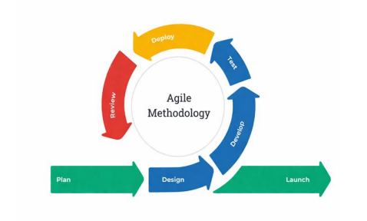
Agile methodology was chosen due to its iterative and flexible nature, allowing continuous refinement of system features based on feedback during development. This is more suitable than traditional models such as Waterfall, which are less adaptable to changing system requirements.
The methodology used in this study is the Agile methodology. Agile emphasizes collaboration, flexibility, iterative development, and rapid delivery of functional system components. It focuses on developing the proposed Automated Document Classification and Tracking System Using Machine Learning into small parts called sprints. Each sprint produces a working version of the system that can be tested and evaluated. The methodology supports the development of system features such as automated document classification, document validation, approval workflow routing, real-time document tracking, and centralized records management. It also focuses on handling evolving requirements and ensuring that system functionalities are developed efficiently throughout the development process. The development process is divided into phases including planning, design, development, testing, deployment, review, and launch.
Phase 1: Planning
The researchers identified the system goals and gathered initial requirements for the proposed Automated Document Classification and Tracking System Using Machine Learning. This phase focused on analyzing the current challenges in manual company records management and determining the necessary system features to address these challenges and improve overall document processing efficiency within organizational settings.
Phase 2: Design
The researchers designed each system module based on the requirements identified during the Planning phase. A Use Case Diagram was developed to illustrate the interactions between the system users – Admin and Staff – and the system, which served as a guide in identifying the functionalities to be developed in each sprint. Data Flow Diagrams were also prepared to define how data moves across the document submission, classification, validation, workflow routing, and archiving processes. An Entity-Relationship Diagram (ERD) was constructed to define the relational structure of the database, covering the tables that support the system's core operations. A Data Dictionary was likewise prepared to document the fields, data types, and relationships of each database table. These design outputs collectively established the structural and functional blueprint of the system prior to development.
Phase 3: Development
This phase focused on the actual construction of the system modules identified during the Design phase. The researchers implemented the automated document classification module using the SVM-TF-IDF machine learning model, along with the document validation, approval workflow routing, SLA-based escalation, real-time tracking, and centralized records repository modules. Development was carried out iteratively through sprints, where each sprint produced a functional version of a system component that was reviewed and refined before proceeding to the next. The system was built using Laravel as the primary web application framework, with its built-in features such as Eloquent ORM, middleware, queued jobs, and blade templating engine providing a structured environment for implementation, together with Laravel Reverb for WebSocket-based real-time broadcasting.
Phase 4: Testing
This phase focused on testing the functionalities and features of the integrated system to ensure that it works properly, performs accurately, and meets the requirements of its intended users across all defined roles and document workflows.
Functional Testing — The researchers conducted functional testing to ensure that all system functions operate correctly and meet the required functionality. Core features including document submission, automated classification, automated validation, approval workflow routing, SLA-based escalation and automated approval, real-time document status tracking, and centralized records retrieval were systematically tested to verify correct system performance. The classification accuracy of the machine learning module was also evaluated to confirm that the system reliably identifies document types without manual intervention.
Phase 5: Deployment
This phase focused on deploying the integrated system to a live cloud hosting environment (Railway), organized as four cooperating services sharing a single MySQL database: a web service handling HTTP requests, a persistent queue worker processing background jobs such as outbound email and delayed SLA escalation, a WebSocket service (Laravel Reverb) handling real-time broadcasting, and a scheduler service running the periodic SLA-sweep and backup tasks. This environment replicated actual company records management operations under realistic, internet-facing conditions rather than only a local development server, and surfaced deployment-specific considerations that a purely local setup would not — for instance, confirming that outbound email delivery required a transactional email provider reached over HTTPS rather than a direct SMTP connection, since the latter was found to be blocked on the hosting platform regardless of provider.
Phase 6: Review
This phase focused on gathering feedback from users and evaluating system performance after deployment to identify any remaining issues or improvements needed before the final system release. The researchers assessed whether all functional requirements have been met and whether the system performs reliably across all defined user roles and document workflows.
Phase 7: Launch
This phase focused on the final release of the system after all modules have been tested, evaluated, and approved. The system will be fully implemented and made available for actual organizational use within the company's records management operations.
System Launch — The finalized Automated Document Classification and Tracking System will be launched for live use. All core functionalities – including automated document classification using the SVM-TF-IDF machine learning model, automated document validation, approval workflow routing, SLA-based escalation and automated approval, real-time document status tracking, centralized digital records repository, and role-based access control for Admin and Staff users – will be made fully operational. The launched system will be accessible as a web-based application, enabling authorized users to submit, classify, track, approve, and retrieve company records entirely through a digital platform without the need for manual sorting, physical handoffs, or paper-based processing.

3.2 Conceptual Framework of the Study
Figure 2. Input Process Output (IPO)
INPUT | ► | PROCESS | ► | OUTPUT  An Automated Document Classification and Tracking System for Company Records Management Using Machine Learning
  Document Submission(Staff)
  • Standardized Doc Templates
  • Text-based Digital Files
  • Document Content
  • Document Type
  Admin Configuration
  • Role-Based Access Control
  • Workflow Rules Setup
  • User Account Management
  • System Settings
  Hardware Requirements:
  • Desktop
  Software Requirements:
  • VS Code, Laravel,
  MySQL, Git/GIthub,
  Figma
  Automated DocumentClassification
  • TF-IDF Vectorization
  • SVM Classification
  • Text Preprocessing
  • Document Type Assignment
  Automated DocumentValidation
  • Required Sections Check
  • Mandatory Fields Verification
  • Formatting Standards Check
  • Pre-Routing Validation
  Document ApprovalWorkflow
  • Automated Routing to Approver
  • Status Tracking
  • Approval / Rejection Handling
  • Audit Trail Maintenance
  System Operations
  • Centralized Repository Storage
  • Document Search & Retrieval
  • Real-time Status Monitoring
  • System Testing & UAT

▲ ▲
FEEDBACK

Figure 2 shows the Conceptual Framework for the "Automated Document Classification and Tracking System Using Machine Learning." This serves as a structured map for building a web-based system that helps organizations manage company documents more efficiently. The framework is divided into three components: Input, Process, and Output.
The Input component consists of two categories. The first is Document Submission by Staff, which includes standardized document templates, text-based digital files, document content, and document type — these serve as the raw materials that the system receives and processes upon submission. The second is Admin Configuration, which covers role-based access control, workflow rules setup, user account management, and system settings — these define the operational parameters that govern how the system behaves for different users and document types. Supporting both categories are the hardware and software requirements necessary for system operation, including desktop workstations and development tools such as VS Code, Laravel, MySQL, Git/GitHub, and Figma.
The Process component is composed of five interconnected operations. First, Automated Document Classification processes each submitted document through text preprocessing, TF-IDF vectorization, and SVM classification to automatically assign the correct document type without manual intervention. Second, Automated Document Validation checks whether the classified document meets the required sections, mandatory fields, and formatting standards before it proceeds to the approval stage. Third, the Document Approval Workflow automatically routes the validated document to the designated approver, handles approval or rejection decisions, tracks document status at each stage, and maintains a complete audit trail throughout the process. Fourth, SLA-Based Escalation and Automated Approval monitors each assignment's computed review window against Admin-configured working hours, working days, and holidays, escalates unresolved assignments to the Admin, and automatically finalizes a stage if even the Admin's grace period elapses, subject to later Admin confirmation or dispute. Fifth, System Operations manage the broader functions of the system, including centralized repository storage, document search and retrieval with live filtering, real-time status broadcasting and in-app notifications, workflow stage configuration and reordering, an audit log viewer, scheduled automated backups with a corresponding restore procedure, and system testing and user acceptance testing.
The Output is a fully functional Automated Document Classification and Tracking System Using Machine Learning — a web-based application that enables authorized users to submit, classify, validate, track, approve, and retrieve company records entirely through a digital platform. A Feedback mechanism connects the output back to both the input and process components, ensuring that user evaluations, system performance results, and identified issues are used to continuously refine and improve the system throughout its development and deployment.

3.3 Hardware and Software Requirements
The hardware specifications listed below outline the minimum and recommended requirements to operate the Automated Document Classification and Tracking System Using Machine Learning efficiently. These components ensure that the system performs well in an organizational environment, supporting document processing, real-time tracking, machine learning classification, and centralized records management.
Table 7. Hardware Requirements for the Automated Document Classification and Tracking System
Component | Minimum Requirements | Recommended Requirements
Processor (CPU) | Intel Core i5 (8th Gen) / AMD Ryzen 5 | Intel Core i7 (11th Gen) / AMD Ryzen 7 or higher (multi-core for ML processing)
RAM | 8 GB DDR4 | 16 GB DDR4 or higher (for handling ML model training and document processing)
Storage | 256 GB SSD | 512 GB SSD or higher (for document storage, database, and ML model files)
Backup Storage | 500 GB External HDD or local backup | 1 TB External HDD or cloud-based backup for document repository redundancy
Monitor | 19" LED Monitor (1080p Full HD) | 21" or larger LED Monitor (Full HD) for improved usability and document review
Internet Connection | Wired LAN / Wi-Fi (minimum 10 Mbps) | Wired LAN / Fiber (25 Mbps or higher) for stable web-based system access
Power Supply | 400W certified PSU | UPS + 500W PSU to ensure uninterrupted system operation during power outages
Peripherals | Standard keyboard and optical mouse | Ergonomic keyboard and mouse for extended organizational use
The listed hardware ensures the system runs efficiently in an organizational environment. Minimum requirements allow the system to function properly for basic document submission, classification, and tracking operations, while the recommended specifications provide better performance, stability, and reliability. A multi-core processor and sufficient RAM are particularly important for supporting the machine learning classification module, which requires additional computational resources during model training and document analysis. Adequate storage ensures that the centralized digital records repository can accommodate growing volumes of approved company documents, while a stable internet connection supports seamless access to the web-based application across all user roles.
Table 8. Software Applications and Their Purpose in System Development
Software | Purpose
Visual Studio Code | Used to write and manage the system's source code, including PHP, HTML, CSS, and JavaScript, with Git integration for version control.
Laravel | Served as the primary PHP web application framework, providing built-in features for routing, authentication, middleware, Eloquent ORM, queued jobs, and system deployment.
php-ai/php-ml | Implemented as the machine learning library for training and deploying the Support Vector Machine (SVC) classifier with TF-IDF feature extraction for automated document classification.
Laravel Reverb | A self-hosted WebSocket server providing real-time broadcasting of document status changes, task assignments, and account verification events directly to open user dashboards, without requiring a manual page refresh.
Brevo | A transactional email service, reached over its HTTPS API, used to deliver account verification links, self-service password reset links, and SLA escalation notices to users' real email addresses.
MySQL | Managed and stored all system data, including document records, user accounts, approval workflow logs, SLA tracking data, and audit trail entries.
Postman | Used to test and debug API requests related to document submission, classification output, and workflow routing within the system.
Figma | Designed the system's UI layouts and prototypes to ensure a user-friendly interface for both Admin and Staff roles.
Git / GitHub | Tracked code changes, enabled team collaboration, and served as a remote repository and backup for the system project.
Windows OS | Main development platform where all tools including Laravel, Visual Studio Code, and MySQL were installed and operated.
Tesseract OCR | Optical Character Recognition engine, invoked through a PHP wrapper, used as the fallback text-extraction path for scanned or image-based documents that have no extractable native text layer.
The development of the Automated Document Classification and Tracking System relied on several essential software tools that supported each phase of the system lifecycle. Visual Studio Code served as the primary code editor for writing and managing source files, while Laravel provided the framework for building a secure, structured, and scalable web-based system with built-in support for authentication, routing, and database management. php-ai/php-ml enabled the integration of the machine learning classification module directly within the PHP environment, supporting SVM-based document classification with TF-IDF feature extraction. Laravel Reverb provided the WebSocket infrastructure needed to push status changes to users' dashboards the moment they occur, rather than only on the next manual refresh. Brevo's HTTPS-based email API was used specifically because it was found, during actual deployment, to work reliably from the hosting environment in a way that direct SMTP connections did not. MySQL handled all data storage and retrieval operations, including document records and workflow tracking logs. Postman was used for testing system endpoints to ensure proper data flow between components. Figma facilitated the design of user-friendly interfaces tailored to the Admin and Staff roles, and Git/GitHub managed version control and team collaboration throughout the development process. Tesseract OCR, invoked through its PHP wrapper, supplied the OCR fallback referenced in the Hybrid Extraction Pipeline (Scope 1.4). All tools were operated on Windows OS, which served as the primary development environment.

3.4 Context Diagram (Existing vs. Proposed)
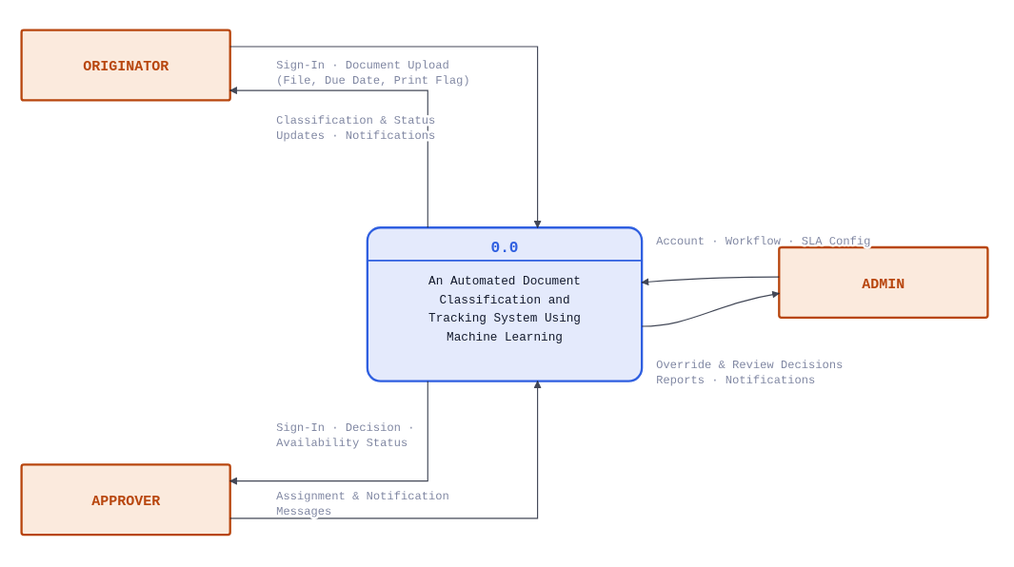
Figure 3. Proposed System Context Diagram Level 0
The Proposed System DFD Level 0, establishes the outer boundary of the Document Classification and Tracking System, treating the entire application as a single process — 0.0, Document Classification & Tracking System — and defining exactly three parties that exchange information across that boundary. The Originator is the party who introduces work into the system: they sign in, submit document files together with a due date, and in return receive classification results, live status updates, and notifications as their submission moves through the pipeline. The Approver sits on the receiving end of that pipeline — they authenticate, set their own availability, and are handed assignment notifications and decision requests, to which they respond with an approve or reject decision. The Admin stands outside the document's day-to-day journey but governs the conditions under which it happens: they create accounts, configure the workflow and SLA rules, and step in with override or review decisions whenever the system's own automation needs a human judgment call, receiving reports and escalation notifications in return.

3.5 Data Flow Diagram (Existing vs. Proposed)

User Design
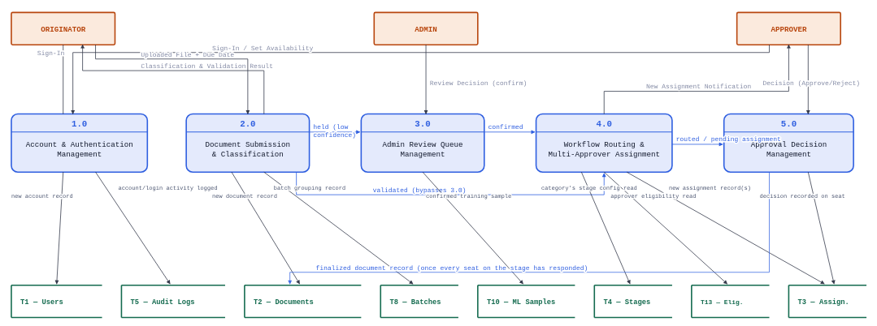
Figure 4. Proposed System Context Diagram Level 1 (Process 1.0 - 5.0)
The Proposed System DFD Level 1 (Process 1.0 - 5.0) provides a detailed breakdown of the system's entry and initial processing stages, decomposing the front half of the document's lifecycle into five specialized processes. The journey begins with Process 1.0 (Account & Authentication Management), where the Admin supplies new account credentials that populate the Users table (T1) while the activity is simultaneously recorded in the Audit Logs (T5) to preserve a secure history of every account created. A newly created account remains unusable until its verification email is confirmed; that same process also governs everyday sign-in for all three roles and lets an Approver toggle their own availability, both changes written straight back into T1.
Once authenticated, the Originator engages Process 2.0 (Document Submission & Classification) by uploading a document together with a due date. This process extracts the text, classifies it against the active model, and validates its content, writing the resulting record into the Document Repository (T2) and a new batch entry into T8 if multiple files were submitted together — with every step logged to T5. A document that clears both checks moves directly to routing; one that doesn't is held instead and handed to Process 3.0 (Admin Review Queue Management), where an Admin confirms the category or content quality by hand. A confirmed document is staged as a training sample in T10 — but only once per document, even if it needed both checks — before it, too, continues on to routing.
Every validated or confirmed document then reaches Process 4.0 (Workflow Routing & Multi-Approver Assignment), which reads the category's configured stages from T4 and every eligible approver's restrictions from T13 to assign the document to every qualified approver on a stage at once — not a single load-balanced pick — while computing a shared, tiered SLA deadline for the whole stage. Each seat is written to Document Assignments (T3), and the approver is notified. From there, Process 5.0 (Approval Decision Management) takes over: an Approver's decision updates their own seat in T3, but the document itself is only finalized in T2 once every seat on a stage has responded — and if any single approver rejects, the whole document is rejected immediately, cascading closed across every other still-pending seat regardless of stage. Both Process 3.0's, 4.0's, and 5.0's outcomes also trigger a notification — a flow that continues off this diagram to Process 7.0 on Level 1 (Process 6.0 - 10.0).

Figure 5. Proposed System Context Diagram Level 1 (Process 6.0 - 10.0)
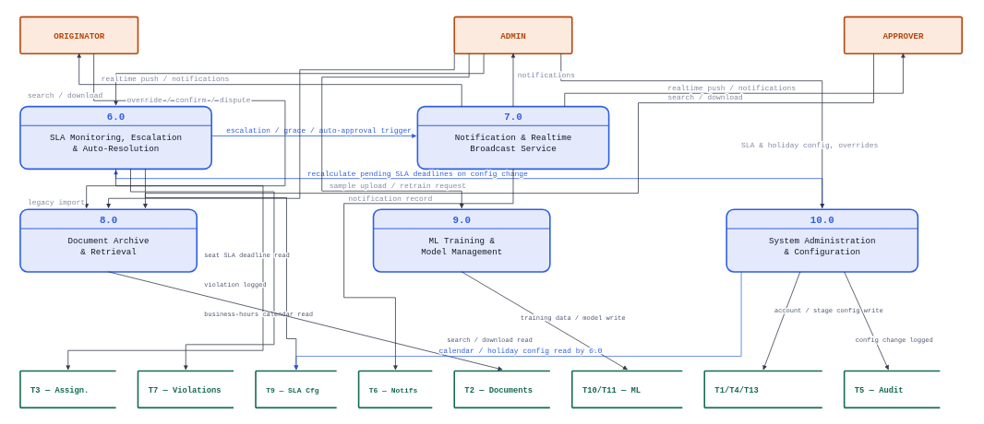
The Proposed System DFD Level 1 (Process 6.0 - 10.0) covers the half of the system that keeps the pipeline honest after a document has already been routed, and that supports it from the outside — retrieval, model training, and administration. At the center of this half sits Process 6.0 (SLA Monitoring, Escalation & Auto-Resolution), which continuously reads each pending seat's deadline from Document Assignments (T3) against the business-hours calendar in T9. An expired seat is flagged, escalated and logged as a violation in T7; if the Admin's own grace window then also lapses, the stage is auto-approved without further human input. This same process independently handles a seat left orphaned by a deactivated approver with no replacement — giving it its own SLA deadline and escalating it exactly the same way, without a violation ever being logged against the approver who departed — and follows up once, near the deadline, on anything still unresolved.
Every one of these events, along with ordinary decisions and new assignments from the other nine processes, flows into Process 7.0 (Notification & Realtime Broadcast Service), which writes a record to Notifications (T6) and pushes it to the relevant user's screen instantly, falling back to a periodic check only if that live connection is down; email is reserved specifically for account verification and password resets, not for operational alerts. In parallel, Process 8.0 (Document Archive & Retrieval) lets any of the three roles search, filter, and download already-approved records from T2, and lets an Admin import a pre-existing, already-approved paper document directly into the archive, bypassing classification and workflow entirely.
Process 9.0 (ML Training & Model Management) is where the classifier itself improves: an Admin stages confirmed samples and triggers a retrain, producing a new model version; the same process lets a previously flagged document be rechecked against whatever model is active now. Finally, Process 10.0 (System Administration & Configuration) is the Admin's control surface for everything structural — user accounts and category assignments in T1/T13, workflow stage definitions in T4, and the business-hours calendar in T9 — and any change to that calendar feeds directly back into Process 6.0, so every pending deadline is recalculated against the new rules rather than left stale.
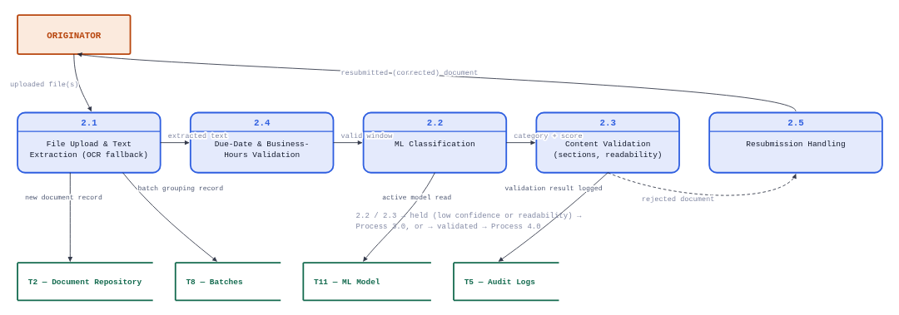
Figure 6. Proposed System Context Diagram Level 2 (Process 2.0)

The Proposed System DFD Level 2 (Process 2.0) exposes a genuine five-step pipeline rather than one atomic action. Sub-process 2.1 receives the Originator's uploaded file and extracts its text, falling back to OCR for scanned or image-based documents, and writes the initial record into the Document Repository (T2) — grouped, where relevant, into a shared batch record in T8.
Sub-process 2.4 independently validates the requested due date against the business-hours calendar, rejecting it outright rather than silently shifting it if it falls too soon or outside working hours. Sub-process 2.2 then classifies the extracted text against the currently active model fetched from the ML Model Repository (T11), and Sub-process 2.3 checks the result against the category's required sections, minimum word count, and a readability heuristic. A document that fails either check by a low margin is held rather than rejected outright, and handed to Process 3.0 for a human decision; one that passes continues straight to Process 4.0. Sub-process 2.5 handles the separate case of a rejected document being resubmitted, linking the corrected version back to its original as a new version rather than treating it as an unrelated upload.
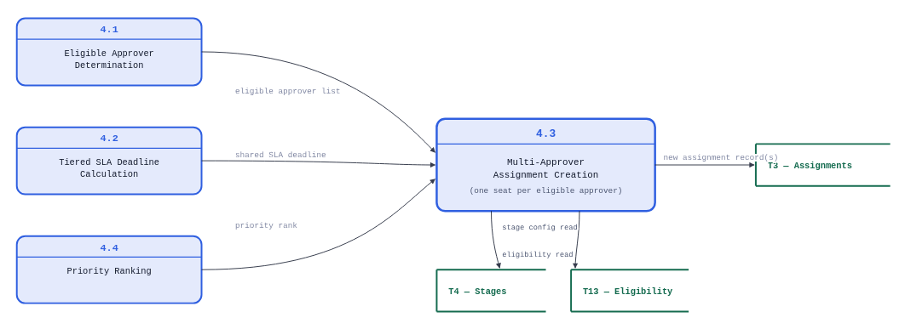
Figure 7. Proposed System Context Diagram Level 2 (Process 4.0)
The Proposed System DFD Level 2 (Process 4.0) is where the system's unanimous-approval design actually gets built. Sub-process 4.1 reads the category's configured stages from Workflow Stages (T4) and cross-references every approver's stage restrictions in T13, returning the complete list of eligible approvers for a stage rather than selecting a single one. In parallel, Sub-process 4.2 computes a single SLA deadline for the whole stage using a tiered formula — twenty-five percent of the time remaining before the document's due date, capped at six hours, with a flat fifteen-minute floor once less than an hour remains — while Sub-process 4.4 derives a priority rank from that same due date. Sub-process 4.3 brings all three outputs together, writing one new record into Document Assignments (T3) for every eligible approver, all sharing the identical deadline computed once rather than recalculated per approver — the detail that makes the stage's later unanimous-approval check (Process 5.2) meaningful in the first place.
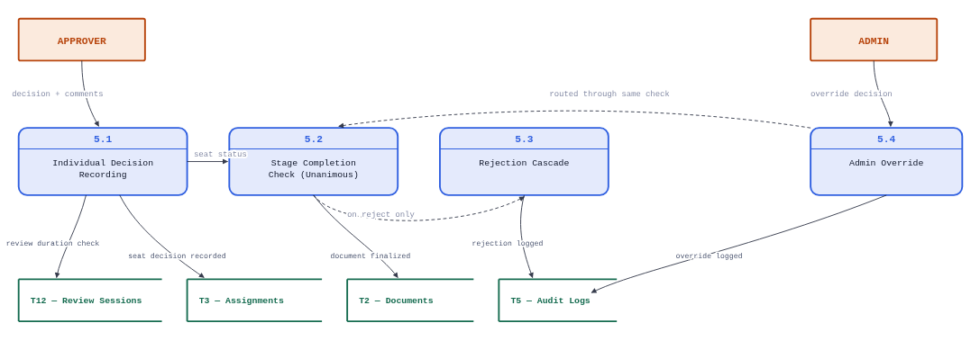
Figure 8. Proposed System Context Diagram Level 2 (Process 5.0)
The Proposed System DFD Level 2 (Process 4.0) governs how an individual decision becomes a finalized outcome for the whole document. Sub-process 5.1 records an Approver's decision against their own seat in Document Assignments (T3) — first confirming a minimum review time has actually elapsed via T12 — and logs it to T5. That decision alone does not finalize anything: Sub-process 5.2 checks whether every seat on that same stage has now responded, and only once all of them have does the document's status in the Document Repository (T2) actually change. If the decision was a rejection, Sub-process 5.3 triggers instead — the entire document is rejected immediately, and every other still-pending seat, on any stage, is cascade-closed at the same moment, so a single rejection can never be silently outrun by other approvers still working through their own seats. Sub-process 5.4 exists alongside this as the Admin's own path to resolve a specific stuck seat directly, routed through the same finalization logic as an ordinary decision.

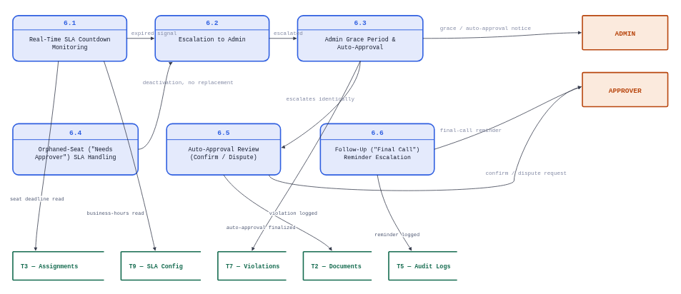
Figure 9. Proposed System Context Diagram Level 2 (Process 6.0)
The Proposed System DFD Level 2 (Process 6.0) is the single most intricate process in the system, and its decomposition reflects that. Sub-process 6.1 continuously checks every pending seat in Document Assignments (T3) against the business-hours calendar in T9, and hands any expired seat to Sub-process 6.2, which flags it escalated, logs a violation to T7, and notifies the Admin. Sub-process 6.3 then governs the grace window that follows: if the Admin does not act before it lapses, the stage is auto-approved directly in the Document Repository (T2) — and that grace window is deliberately halved, rather than left at its full flat length, whenever the document's due date is close enough that the full window would otherwise consume the entire remaining time, preserving a real window afterward for a human to actually review what just happened.
Sub-process 6.4 handles a related but distinct situation: a seat left with no eligible approver at all, typically after a deactivation with no replacement available. It receives its own SLA deadline and escalates through the same path as 6.2 once that deadline passes — deliberately without logging a violation against the departed approver, since the delay was never their doing. Sub-process 6.5 is the human follow-through after an auto-approval: an Admin either confirms it or disputes it, the outcome recorded back against the assignment. Finally, Sub-process 6.6 exists purely to close a gap the others leave open — both the original escalation notice and the auto-approval notice are one-time alerts, so this sub-process sends exactly one additional "final call" reminder as the real deadline draws close, to whichever party still hasn't acted.

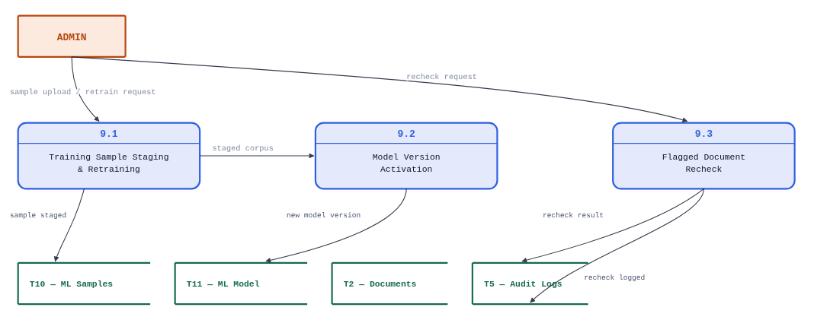
Figure 10. Proposed System Context Diagram Level 2 (Process 7.0)
The Proposed System DFD Level 2 (Process 9.0) covers the two genuinely distinct ways the Admin interacts with the classifier itself. Sub-process 9.1 stages confirmed documents into ML Staging Samples (T10) and, on request, retrains the classifier against that accumulated corpus, producing a new candidate model. Sub-process 9.2 takes that output and writes it into the ML Model Repository (T11) as a new version, becoming the model every future classification in Process 2.2 is measured against. Sub-process 9.3 is the odd one out and the reason this process earns its own decomposition at all: it lets an Admin re-run a document that was previously flagged for low confidence against whichever model is active right now, closing the loop between "we improved the model" and "did it actually fix the cases that prompted the improvement" — without needing the document to be resubmitted from scratch.

Data Gathering Tools and Procedures
The researchers employed several data gathering methods to collect the necessary information for the development of the proposed Automated Document Classification and Tracking System Using Machine Learning. These methods ensured an accurate understanding of the current document management and approval workflow practices within the organization. The respondents consisted of one (1) company supervisor who are directly involved in document processing and approval workflows, making them suitable sources of information for identifying system requirements. The researchers visited the company and conducted interviews to collect information about how documents are currently handled, processed, and approved. The collected data provided insights into the system requirements, existing inefficiencies, and user expectations for both the classification and tracking functionalities of the proposed system. These data gathering methods were selected to obtain both qualitative and contextual insights into the existing document workflow, ensuring that system requirements are based on actual organizational practices.
The following data gathering tools were utilized:
Interview – The researchers conducted interviews with the company's supervisor and leadman to gather detailed information about the current document management process. The interview focused on three primary areas: how company documents are handled and filed, how the approval process flows from submission to final authorization, and whether delays are commonly experienced throughout the process. The respondents confirmed that document handling follows the standard procedures typical of company records management, though they were unable to provide physical copies of actual documents due to confidentiality. Through the interview, the researchers identified that the current manual process is prone to delays in approval routing, difficulty in tracking document status, and the absence of a systematic classification mechanism, all of which served as the primary basis for the proposed system's feature design.
Questionnaire – A structured questionnaire was administered to support and validate the data collected from the interviews. The questionnaire focused on identifying common challenges in document handling, including delays in processing, difficulty in tracking document status, inefficiencies in document retrieval, and issues in maintaining organized records. The responses reinforced the findings from the interview and provided additional evidence that the existing manual system lacks efficiency, traceability, and proper classification mechanisms. The questionnaire consisted of structured questions focusing on delays, tracking issues, document retrieval efficiency, and record organization.
Observation – The researchers observed the step-by-step document lifecycle, including submission, validation, approval, rejection, and archiving, to identify bottlenecks and inefficiencies in the manual process. This allowed the researchers to map the existing document lifecycle and identify the key stages where automation could most significantly improve efficiency.
The collected data were analyzed and translated into system features such as automated classification, validation, workflow routing, and real-time tracking.

3.6 Activity Diagram
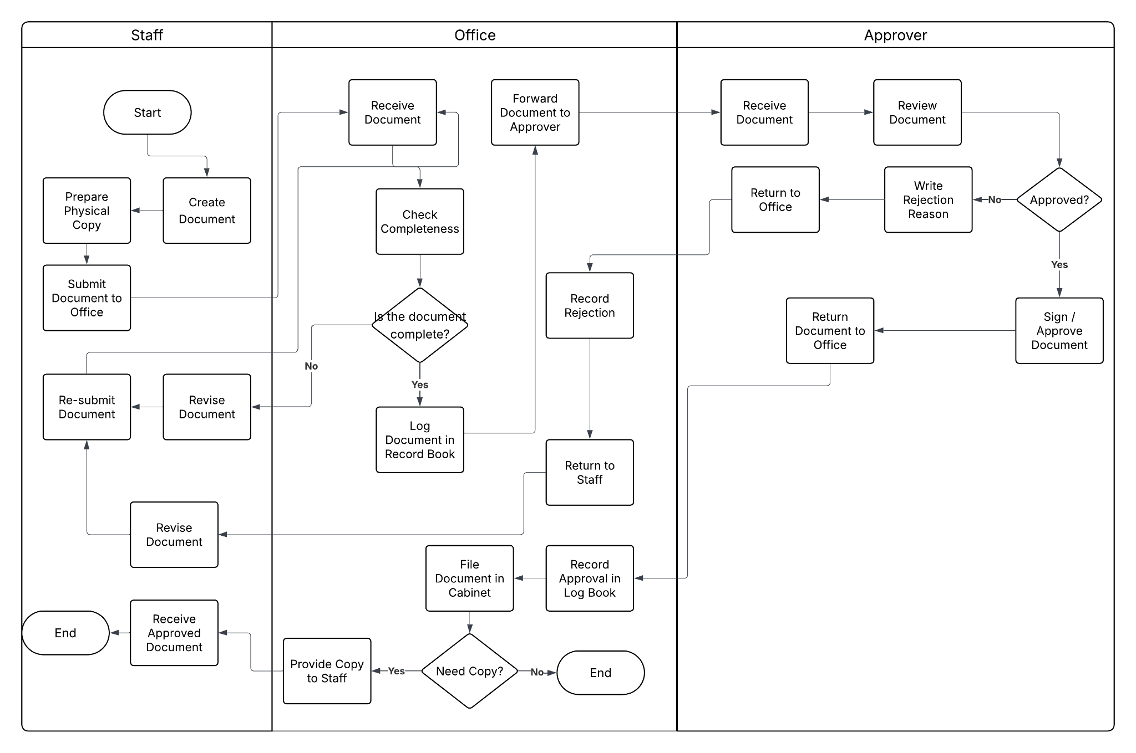
Figure 11. Activity Diagram of the Existing System
The existing system of the organization follows a manual, paper-based document handling and approval process, as illustrated in Figure 7. In this process, the staff (originator) prepares and submits physical documents such as job orders, purchase requisitions, and service reports to the office or records staff. Upon receiving the document, the records staff checks its completeness. If the document is incomplete, it is returned to the originator for revision and resubmission. If complete, the document is logged in a record book and forwarded to the department head or approver for review.
The approver manually evaluates the document and decides whether to approve or reject it. If rejected, the approver provides a reason and returns the document to the office, which then records the rejection and sends it back to the originator for revision. This cycle continues until the document meets the required standards. Once approved, the document is signed and returned to the office, where it is recorded in the logbook and stored in a physical filing cabinet. If needed, a copy of the approved document is provided to the staff.
This manual process involves multiple handoffs, repetitive steps, and physical document movement, which may lead to delays, difficulty in tracking document status, risk of document loss, and inefficiencies in records management.
To support the development of the proposed system, the researchers gathered the necessary data through interviews and observation. Interviews were conducted with the company's supervisor and leadman to identify the current document handling practices, approval workflow procedures, and common challenges encountered in managing records. Additionally, observation was carried out to understand how documents are processed, routed, and stored within the organization.
The respondents confirmed that the organization follows standard manual procedures in document processing. Due to confidentiality constraints, actual documents were not provided; however, their structure and content were described in detail and used to construct a representative dataset for training the SVM–TF-IDF classifier.
A structured questionnaire was also administered to identify common issues such as delays, difficulty in tracking document status, and inefficiencies in document organization. The responses supported and validated the findings from the interviews.
The collected data served as the basis for defining the system requirements and designing the core functionalities of the proposed Automated Document Classification and Tracking System, including classification, validation, workflow routing, tracking, and centralized storage.

System Architecture Design
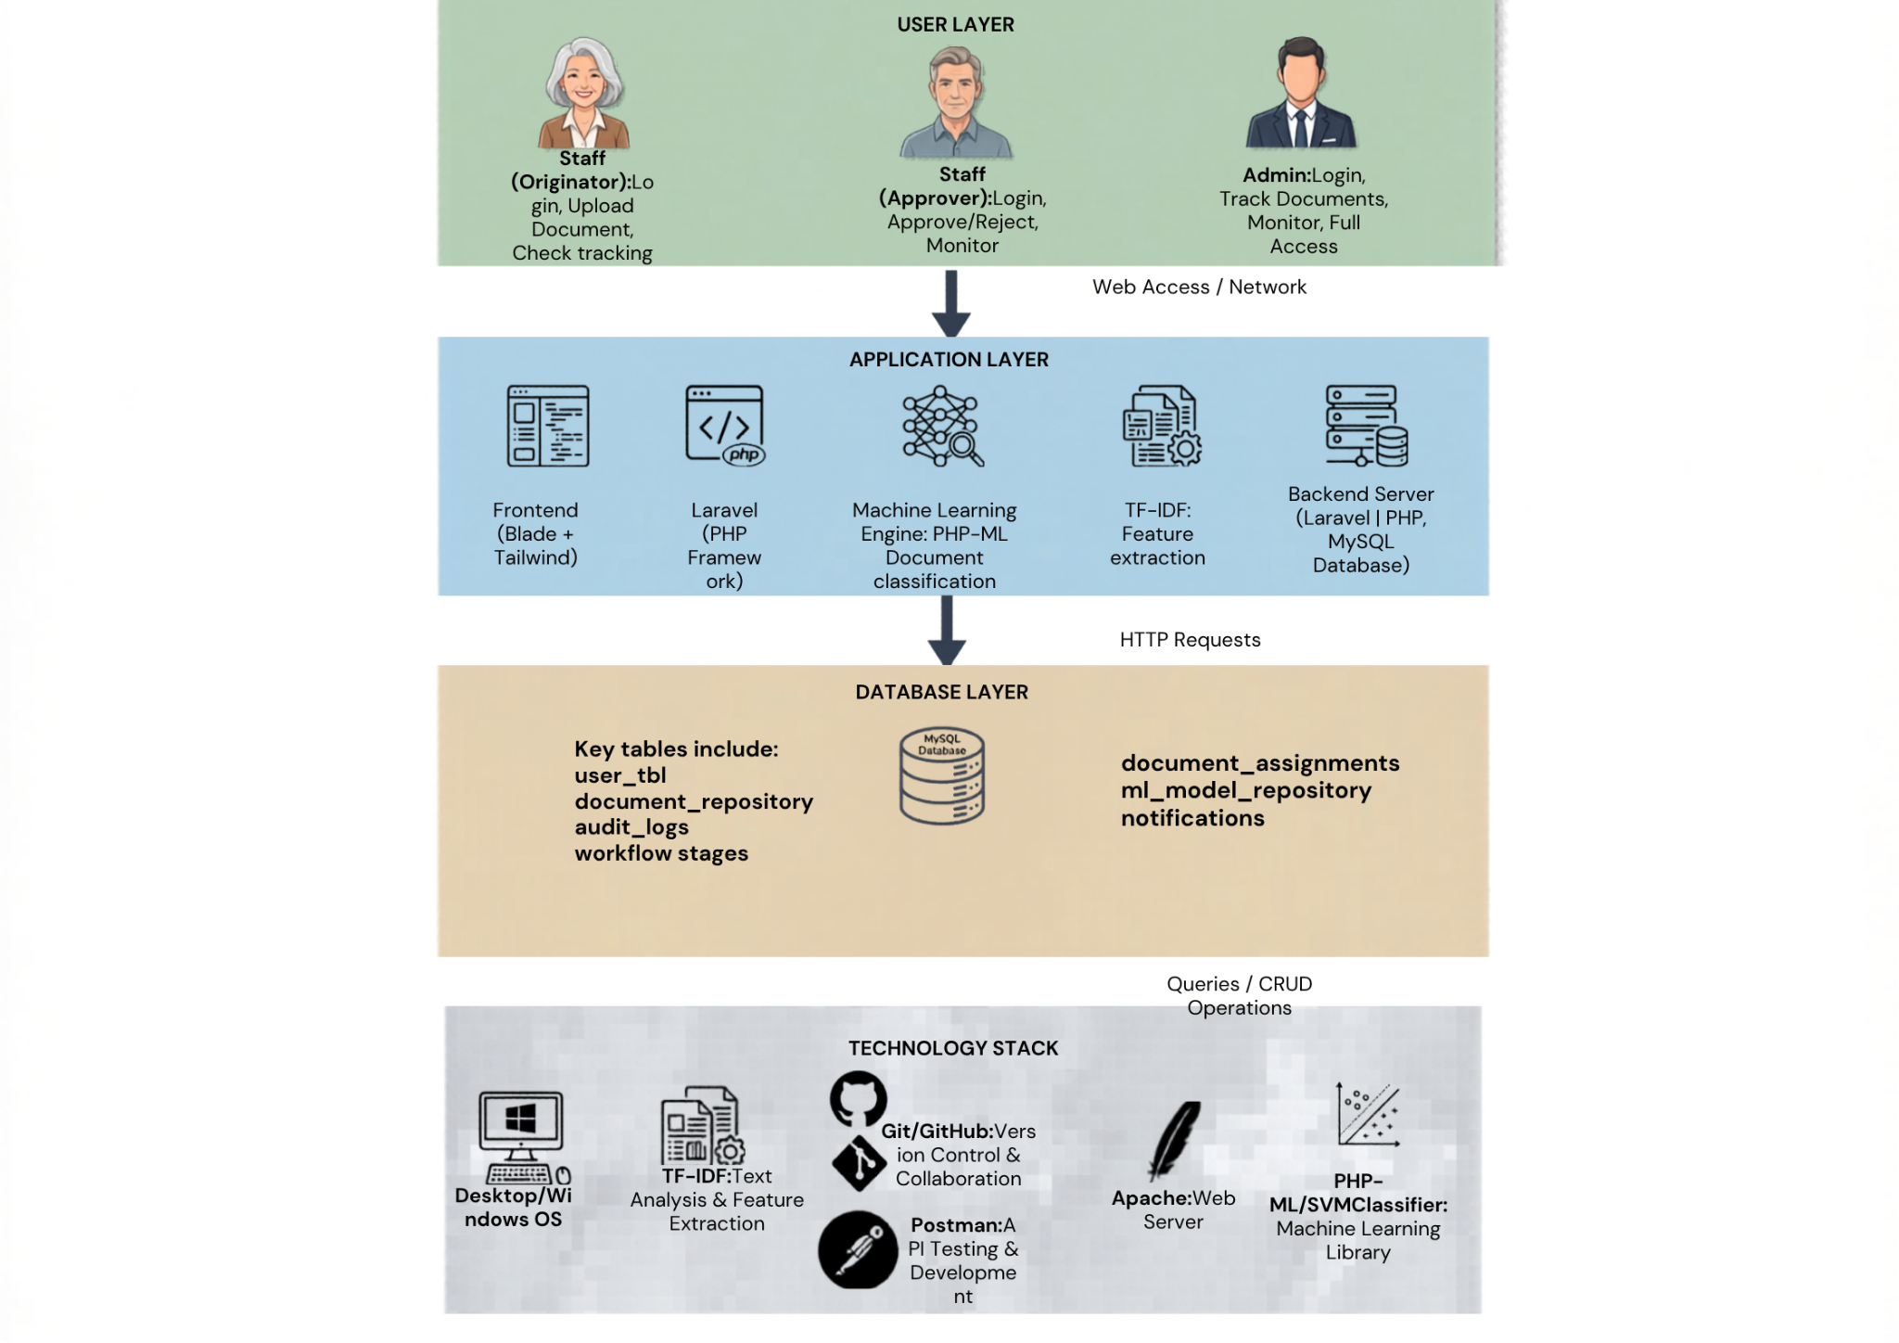
Figure 12. System Architecture Diagram
The system adopts a layered architecture consisting of the User Layer, Application Layer, Database Layer, and Technology Stack.
The User Layer includes the Staff (Originator), Staff (Approver), and Admin, who interact with the system to upload, review, track, and manage documents.
The Application Layer handles core system processes, including the frontend interface (Blade and Tailwind), backend logic (Laravel), the machine learning module, where TF-IDF is used for feature extraction and SVM for document classification, a background queue worker responsible for sending outbound email and processing delayed SLA-escalation jobs, and a WebSocket broadcasting service (Laravel Reverb) responsible for pushing real-time status updates to connected clients.
The Database Layer manages all system data using MySQL, including users, documents, workflow stages, assignments, audit logs, notifications, SLA configuration and violation records, and model records.
The Technology Stack comprises the technologies used to develop and deploy the system, such as Laravel, PHP, MySQL, Apache, php-ai/php-ml, Laravel Reverb, and the Brevo email API.
Overall, the architecture supports automated document classification, efficient workflow processing, SLA-aware escalation, real-time status broadcasting, and centralized document management.
User Roles and Document Routing Strategy
DocTrack classifies users into three distinct roles based on their responsibilities:
1. Staff-Originator – Users who submit documents for approval and track their processing status.
2. Staff-Approver – Users assigned to review, validate, and approve documents based on their assigned document category (Job Order, Purchase Requisition, or Service Report).
3. Administrator – System managers who configure workflows, manage user accounts, train the ML model, and monitor system performance.
Rather than organizing users by department, DocTrack uses role-based and category-based routing. This approach offers significant advantages over department-based routing: reduced system maintenance since employee transfers between departments do not require workflow reconfiguration, elimination of approval bottlenecks through load-balanced assignment to available approvers, and expertise-based approval routing where documents are assigned to approvers based on their category competency regardless of department affiliation. By centralizing administration under a single admin role and routing documents based on category assignment rather than organizational structure, DocTrack remains flexible, scalable, and independent of departmental reorganization.

3.7 Entity Relationship Diagram
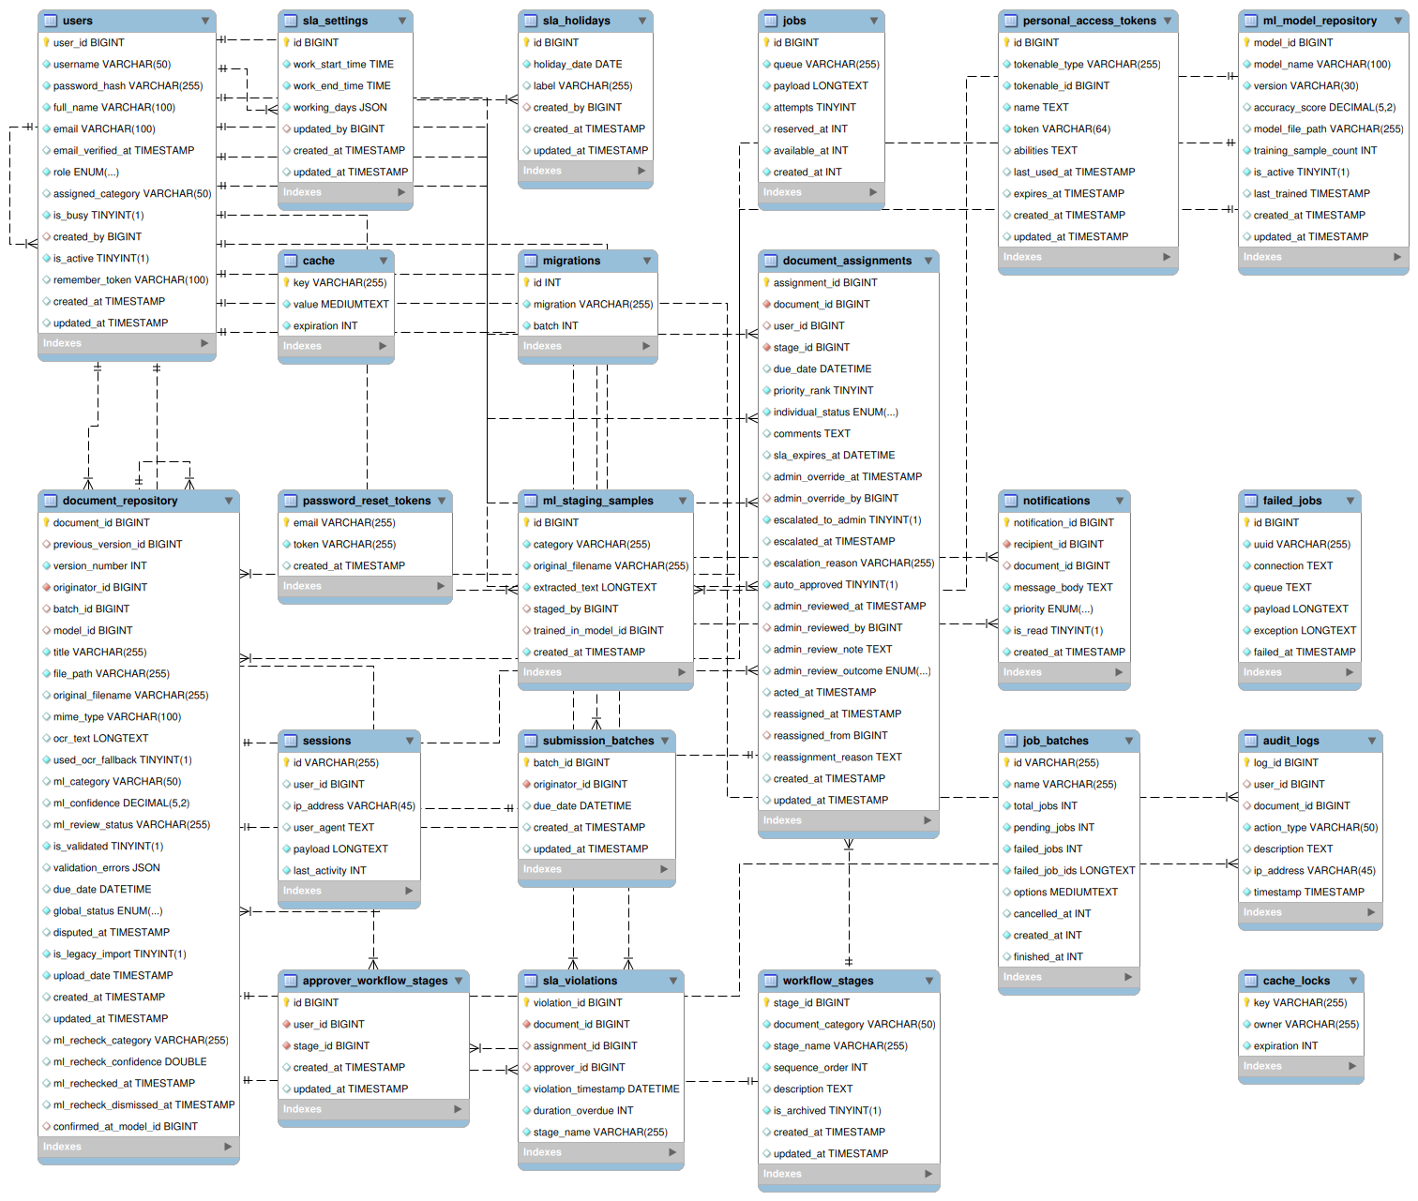
Figure 13. E.R. Diagram of the Proposed System
The Entity Relationship Diagram (ERD) of the Automated Document Classification and Tracking System Using Machine Learning illustrates a structured relational database designed to manage the lifecycle of a document from ingestion to final approval. At the center of the architecture is the Users table, which acts as the primary identity provider by storing account credentials, roles, and administrative metadata. This table shares several one-to-many (1:M) relationships, linking a single user to multiple uploads in the Document_Repository, multiple review tasks in Document_Assignments, and numerous entries in the Audit_Logs and Notifications tables. These connections ensure that every document is tied to an originator and every assignment is linked to a specific approver, facilitating secure role-based access and accountability. An account's role restricts what it may do, but its ability to log in at all is gated separately by whether its email address has been verified — an unverified account exists in the Users table but cannot authenticate until that is resolved.
The Document_Repository serves as the core data hub, containing the physical file paths, extracted OCR text, and machine learning classification results. It is linked to the ML_Model_Repository in a one-to-many relationship, where a single version of an SVM-TF-IDF classifier can be used to categorize a vast library of documents while maintaining an audit trail of the AI version used for each file. Furthermore, the repository connects to the Document_Assignments table, allowing a single document to be distributed across various workflow stages as defined in the Workflow_Stages table. A new Approver_Workflow_Stages pivot table sits between Users and Workflow_Stages, allowing an individual approver to be restricted to only specific stages within their assigned category rather than every stage in it. Documents submitted together in one sitting are additionally grouped under a Submission_Batches table, which an Originator's upload is linked to, so that several files submitted at once share a single due date and are tracked as one logical submission.
To maintain system transparency and real-time coordination, the database incorporates comprehensive logging and alerting mechanisms. The Audit_Logs table maintains a forensic record of every action performed by users or the system, such as document uploads or approval decisions, by linking directly to both the Users and Document_Repository tables. Simultaneously, the Notifications table manages the communication queue, storing prioritized alerts that inform originators of status changes and notify approvers of new assignments. A dedicated SLA subsystem — comprising Sla_Settings (the configurable working-hours window), Sla_Holidays (non-working dates), and Sla_Violations (a record of each detected breach, linked back to the specific document and, where available, the specific assignment) — supports the escalation and automated-approval behavior described in Scope (1.4). Document_Assignments itself carries an escalation timestamp and a set of Admin-review fields (reviewed-at, reviewed-by, a note, and an outcome of confirmed or disputed), recording what happened when the Admin later reviewed a stage the system had auto-approved. A companion Disputed_At timestamp on Document_Repository records that a document has been flagged this way without altering its original approval outcome. Finally, an Ml_Staging_Samples table supports the Admin's ongoing collection of labeled training samples per category ahead of retraining the classifier, and standard Laravel framework tables — Password_Reset_Tokens (self-service password reset), Sessions (authenticated session storage), and Jobs/Job_Batches/Failed_Jobs (the background queue that processes outbound email and delayed SLA jobs) — support the system's authentication and asynchronous-processing infrastructure. Together, these tables form a cohesive ecosystem that automates document classification and tracking while ensuring every transaction is authenticated, authorized, and audited.

3.8 Use Case Diagram
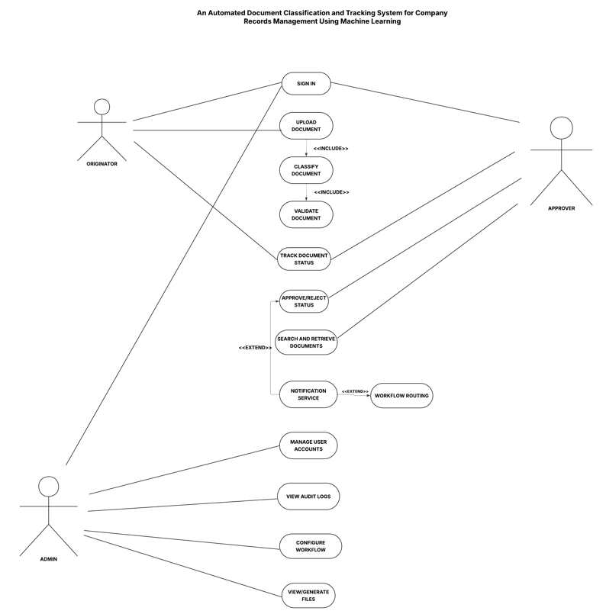
Figure 14. Use Case Diagram of the Proposed System

The Use Case Diagram for the Automated Document Classification and Tracking System for Company Records illustrates a streamlined workflow managed by three primary actors. The process begins with the Originator, who performs the Upload Document task. This action automatically triggers the Classify Document and Validate Document use cases through an include relationship, ensuring every file is processed by the system's logic immediately. The Originator also uses the system to Track Document Status and Search and Retrieve Documents.
The Approver is responsible for the Approve/Reject Status use case to move documents through the pipeline. This process can trigger a Notification Service via an extend relationship, which then initiates Workflow Routing to inform relevant parties of the document's progress. Like the Originator, the Approver has access to search and tracking tools to monitor the records repository. If an Approver does not act within their assignment's review window, the same pipeline escalates the assignment to the Admin rather than leaving it with the Approver indefinitely.
The Admin manages the system's backend and overall security. Their role involves the Manage User Accounts use case, monitoring activity through View Audit Logs, and setting system rules via Configure Workflow. The Admin additionally reviews any assignment the system auto-approved on its own — confirming it as routine or disputing it — and can View/Generate Files for reporting purposes. Together, these interactions show how the system uses machine learning to automate record-keeping while maintaining human oversight.

3.9 Data Dictionary
Table 9. Database Table of User Information
Fieldname | Description | Data Type | Type of Key
user_id | Unique identifier for each system user. | int | Primary Key
username | The unique string used by the user to log into the application. | varchar(50) | -
password_hash | A secure, salted, and hashed version of the user's password. | varchar(255) | -
full_name | The legal or display name of the user for identification in tracking. | varchar(100) | -
email | The contact address used for system alerts, notifications, account verification, and password reset. | varchar(100) | -
email_verified_at | Timestamp recording when the account owner confirmed their email address. Null means the account is not yet verified and cannot log in. | timestamp (nullable) | -
role | Defines the user's access level (Admin, Originator, or Approver). | varchar(20) | -
assigned_category | The single document category (e.g., Job Order) an Originator or Approver account is restricted for Archive filtering and, for Approvers, routing eligibility. Not applicable to Admin accounts. | varchar(50), nullable | -
is_busy | Manual availability flag an Approver may toggle to indicate they are temporarily unavailable, used by the routing logic to prefer an available peer. | boolean | -
created_by | The Admin account that created this account, for administrative traceability. | int, nullable | Foreign Key
is_active | Whether the account may currently be used to log in; an Admin may deactivate an account without deleting it. | boolean | -
remember_token | Token supporting the "remember me" persistent-login option. | varchar(100), nullable | -
This table serves as the primary identity provider and central registry for all registered user accounts within the system. By consolidating roles directly within the user record, the system simplifies access control logic and ensures efficient role-based permission management. It is the primary data store utilized by DFD Process 1.0 to handle authentication, profile management, and secure login verification, and by Process 2.0 for both sign-in and self-service password reset. Additionally, it tracks administrative metadata to identify which administrator originally created each specific account, and gates login entirely on the account's email having been verified.
Table 10. Database Table of Document Repository
Fieldname | Description | Data Type | Type of Key
document_id | Unique identifier for each record in the repository. | int | Primary Key
originator_id | Links the document to the User who originally uploaded it. | int | Foreign Key
batch_id | Links the document to the submission batch it was uploaded together with, when submitted alongside other files in the same request. | int, nullable | Foreign Key
model_id | Identifies which ML model version was used for classification. | int | Foreign Key
previous_version_id | Links a resubmitted document back to the earlier version it revises, forming a version history chain. | int, nullable | Foreign Key (self)
version_number | A 1-based counter indicating this document's position along its version chain. | int | -
title | The user-defined or system-generated name for the record. | varchar(255) | -
file_path | The server path or URL where the physical file is stored. | varchar(255) | -
ocr_text | The raw string of text captured through either Direct Extraction or OCR fallback, which serves as the input for the ML classification model. | text | -
ml_category | The specific document class (e.g., Job Order, Purchase Requisition, Service Report) predicted by the ML model. | varchar(50) | -
due_date | The deadline set by the originator at submission, used by the SLA calculation to determine each stage's review window. | date | -
global_status | The high-level state of the file (e.g., Pending, Approved, Auto-Approved, Rejected, Archived). | varchar(20) | -
is_legacy_import | Marks a document that an Admin imported directly as already-approved, bypassing classification and the approval workflow, so the interface can visibly distinguish it from a peer-reviewed record. | boolean | -
disputed_at | Timestamp recording that an Admin has flagged this document's auto-approved outcome as disputed. Does not change global_status, preserving the historical fact that the document was auto-approved. | timestamp, nullable | -
ml_review_status, ml_recheck_category, ml_recheck_confidence, ml_rechecked_at, ml_recheck_dismissed_at, confirmed_at_model_id | Support the Admin's review of low-confidence classifications: whether a document is flagged for review, the result of re-running classification after the model is retrained, and which model version was active when the flag was last confirmed. | mixed (see migration) | -
upload_date | The exact timestamp of when the file was first received. | timestamp | -
This table acts as the central repository for all digital records and processed metadata within the system. It stores critical physical file metadata, the raw text string extracted via OCR, and the specific classification results generated by the machine learning engine. The table also holds the due_date attribute, essential for the system's SLA calculation logic, and now carries a version chain, a legacy-import flag, and a dispute flag layered on top of the document's original, unaltered approval outcome. This data store is vital for maintaining a complete history of all records from the moment they are uploaded by an originator.
Table 11. Database Table of Workflow Stages
Fieldname | Description | Data Type | Type of Key
stage_id | Unique identifier for each workflow stage definition. | int | Primary Key
stage_name | The name of the stage (e.g., Technical Review, Final Approval). | varchar(255) | None
sequence_order | The numeric order in which this stage occurs. | int | None
description | Detailed explanation of the requirements for this stage. | text | None
is_archived | Marks a stage as retired from active routing while preserving it for historical reporting, since a stage that has ever had an assignment cannot be deleted outright. | boolean | None
This table defines the different sequential stages within the automated document approval process, such as technical reviews or final sign-offs. It provides the configuration data needed by Process 4.0 to ensure that documents follow the correct departmental or organizational path. Each record specifies the order of operations and the requirements necessary for a document to clear that specific stage. This structure allows the system to remain flexible if the organizational workflow needs to be updated or expanded in the future, while retaining a full history of stages no longer in active use.
Table 12. Database Table of Approver Workflow Stages
Fieldname | Description | Data Type | Type of Key
id | Unique identifier for the assignment record. | int | Primary Key
user_id | Links to the Approver being scoped to a specific stage. | int | Foreign Key
stage_id | Links to the specific stage this Approver is permitted to handle. | int | Foreign Key
This pivot table allows an Admin to optionally restrict a given Approver to only certain stages within their assigned category, rather than every stage in it — for example, an approver handling only Technical Review but not Final Approval within Job Order. An Approver with no rows in this table remains eligible for every stage in their assigned category, preserving backward-compatible behavior for simple accounts that never needed this finer-grained restriction.
Table 13. Database Table of Submission Batches
Fieldname | Description | Data Type | Type of Key
batch_id | Unique identifier for each grouped submission. | int | Primary Key
originator_id | Links the batch to the Staff (Originator) who submitted it. | int | Foreign Key
due_date | The single deadline the Originator set for every document submitted together in this batch. | datetime, nullable | -
This table groups documents that an Originator uploaded together in a single submission, allowing several files submitted at once to share one deadline and be tracked as a single logical request rather than several unrelated ones. A document uploaded on its own is simply not linked to any batch.
Table 14. Database Table of Document Assignments
Fieldname | Description | Data Type | Type of Key
assignment_id | Unique identifier for a specific review task. | int | Primary Key
document_id | Links the assignment to the specific parent document record. | int | Foreign Key
approver_id | Links the task to the specific Approver responsible for the review. | int | Foreign Key
stage_id | Defines where in the workflow sequence this task falls. | int | Foreign Key
due_date | Mirrored deadline date used for immediate sorting in the user's queue. | date | -
priority_rank | The urgency score calculated by the system. | int | -
individual_status | The status of this specific sign-off (Pending, Approved, Rejected). | varchar(20) | -
escalated_to_admin | Whether this assignment has been escalated to the Admin after its review window elapsed without action. | boolean | -
escalated_at | Timestamp of when this assignment was escalated to Admin, used to compute the remaining Admin grace period and to schedule the automated-approval check. | timestamp, nullable | -
escalation_reason | Distinguishes a genuine SLA breach from an escalation triggered because no eligible replacement approver existed after a reassignment, so the latter is not counted as a violation. | varchar, nullable | -
auto_approved | Whether this stage was finalized automatically by the system after the Admin's own grace period elapsed without action. | boolean | -
admin_reviewed_at, admin_reviewed_by, admin_review_note, admin_review_outcome | Records the Admin's after-the-fact review of an auto-approved stage: when it was reviewed, by whom, any note, and whether it was confirmed as routine or disputed. | mixed (see migration) | admin_reviewed_by is a Foreign Key
reassigned_at, reassigned_from, reassignment_reason | Records that this assignment was automatically handed off to a different approver — for example, after the original approver's account was deactivated while work was still pending. | mixed (see migration) | reassigned_from is a Foreign Key
comments | The text area where an approver provides reasons for rejection or notes. | text | -
acted_at | The timestamp recording exactly when the approver (or the system, in an auto-approval) made the decision. | timestamp | -
This table powers the multi-stage approval workflow, the SLA escalation mechanism, and the Live Tracking module by managing individual tasks assigned to specific approvers. It uses the approver_id as a foreign key to ensure that assignments "stick" to the correct staff account for secure dashboard filtering. Beyond the original approve/reject record, it now also tracks whether and when an assignment escalated to the Admin, whether it was ultimately auto-approved by the system, how the Admin subsequently reviewed that automated decision, and whether the assignment was ever reassigned to a different approver.
Table 15. Database Table of ML Model Repository
Fieldname | Description | Data Type | Type of Key
model_id | Unique identifier for a specific version of a pre-trained model. | int | Primary Key
model_name | The name of the algorithm or model type. | varchar(100) | -
version | The version string for tracking model updates. | varchar(10) | -
accuracy_score | The validated performance metric of the model at the time of deployment. | decimal(5,2) | -
last_trained | The timestamp of the model's last training or update session. | timestamp | -
This entity serves as a specialized metadata store for the system's Machine Learning models and classification versions. It ensures that the system can audit which specific version of a pre-trained algorithm was responsible for categorizing a document at any given time. This table supports overall system transparency and allows administrators to monitor the accuracy and training history of the AI components.
Table 16. Database Table of ML Staging Samples
Fieldname | Description | Data Type | Type of Key
id | Unique identifier for the staged sample. | int | Primary Key
category | The document category this sample is being staged for. | varchar | -
original_filename | The name of the file as originally uploaded by the Admin staging it. | varchar | -
extracted_text | The text extracted from the sample, used when it is later included in a training run. | longtext | -
staged_by | The Admin account that staged this sample. | int, nullable | Foreign Key
trained_in_model | Records whether, and in which model version, this sample was actually used in training. | varies | -
This table provides a shared staging area where Admins accumulate labeled sample documents for a category over time, ahead of retraining the SVM–TF-IDF classifier, rather than losing progress if a browser session or login expires between staging sessions.
Table 17. Database Table of SLA Settings, Holidays, and Violations
Fieldname | Description | Data Type | Type of Key
work_start_time, work_end_time | The organization's configurable daily working window, used to compute business-hours-aware SLA deadlines. | time | -
working_days | Which days of the week count as working days. | json | -
holiday_date, label | A specific non-working date the Admin has marked as a holiday, treated identically to a non-working weekday. | date / varchar | -
violation_id | Unique identifier for a detected SLA breach. | int | Primary Key
document_id, assignment_id, approver_id | Link the violation record back to the specific document, assignment, and approver involved. | int | Foreign Keys
violation_timestamp, duration_overdue, stage_name | When the breach was detected, how many minutes overdue the assignment was, and the name of the stage at the time (kept as a snapshot so the record stays meaningful even if the stage is later renamed). | mixed | -
Together, these three tables implement the business-hours-aware SLA calculation and breach tracking described in Scope (1.4): Sla_Settings and Sla_Holidays define what counts as working time, while Sla_Violations logs every instance in which an assignment's review window was actually breached, supporting the SLA Violations report and providing an auditable accountability record independent of whether the assignment was later escalated, reassigned, or auto-approved.
Table 18. Database Table of Tracking / Audit Logs
Fieldname | Description | Data Type | Type of Key
log_id | Unique identifier for the audit entry. | int | Primary Key
user_id | Links the activity to the specific user who performed the action. | int | Foreign Key
document_id | Links the log to the specific document affected by the action. | int | Foreign Key
action_type | The category of action (e.g., Login, Upload, Approve, Reject, Auto-Approve, Dispute). | varchar(50) | -
description | A narrative summary of the event for human review. | text | -
ip_address | The network address of the user for security and forensic tracking. | varchar(45) | -
timestamp | The precise date and time the event occurred. | timestamp | -
This table provides an immutable and chronological record of all user and system activities for security and compliance purposes. It tracks every significant event, including user logins, document uploads, and approval decisions — whether made by a person or by the system's own automated approval logic — to create a complete forensic trail. By capturing the ip_address and specific action_type, administrators can monitor for unauthorized access or system misuse. This record is essential for verifying the integrity of the automated classification and tracking processes within the organization.
Table 19. Table of Notifications
Fieldname | Description | Data Type | Type of Key
notification_id | Unique identifier for each system-generated alert. | int | Primary Key
recipient_id | The user ID of the person intended to receive the message. | int | Foreign Key
document_id | The document ID related to the notification event. | int | Foreign Key
message_body | The actual text shown to the user in their notification bell/drawer. | text | -
is_read | A flag indicating if the user has viewed the notification. | boolean | -
created_at | The timestamp of when the alert was originally triggered. | timestamp | -
This table manages the communication queue by storing real-time alerts intended for specific system users. It acts as the data source for the Notification Service, ensuring that originators are updated on document status and approvers are notified of new tasks. The table tracks the is_read status of each message to help manage the user interface's notification bell or drawer. By linking each alert to a document_id, users can navigate directly from a notification to the relevant record for immediate action. In-app notifications recorded here are delivered to an open dashboard live over a WebSocket connection; account verification, password reset, and SLA escalation notices are additionally sent as email through the system's transactional email service.

Table 20. Framework-Level Support Tables
Table | Purpose
password_reset_tokens | Stores a time-limited token, keyed by email address, issued when a user requests a self-service password reset link.
sessions | Stores authenticated session state per logged-in user, including their IP address and user agent, for session management and security auditing.
jobs / job_batches | Holds background tasks awaiting processing by the queue worker — chiefly outbound email (verification, password reset, SLA escalation) and delayed SLA-escalation/auto-approval checks — until they are picked up and run.
failed_jobs | Records any background task that failed after its allowed retry attempts, together with the exception raised, so it can be investigated rather than silently disappearing.
These tables are standard Laravel framework infrastructure rather than domain-specific entities, but are necessary for two features described in Scope (1.4) to function at all: self-service password reset (password_reset_tokens, sessions) and the asynchronous delivery of outbound email and delayed SLA processing (jobs, job_batches, failed_jobs), which run on a separate persistent background process from the main web application so that sending an email or scheduling a future escalation check never blocks a user's own request.

3.10 Gantt Chart
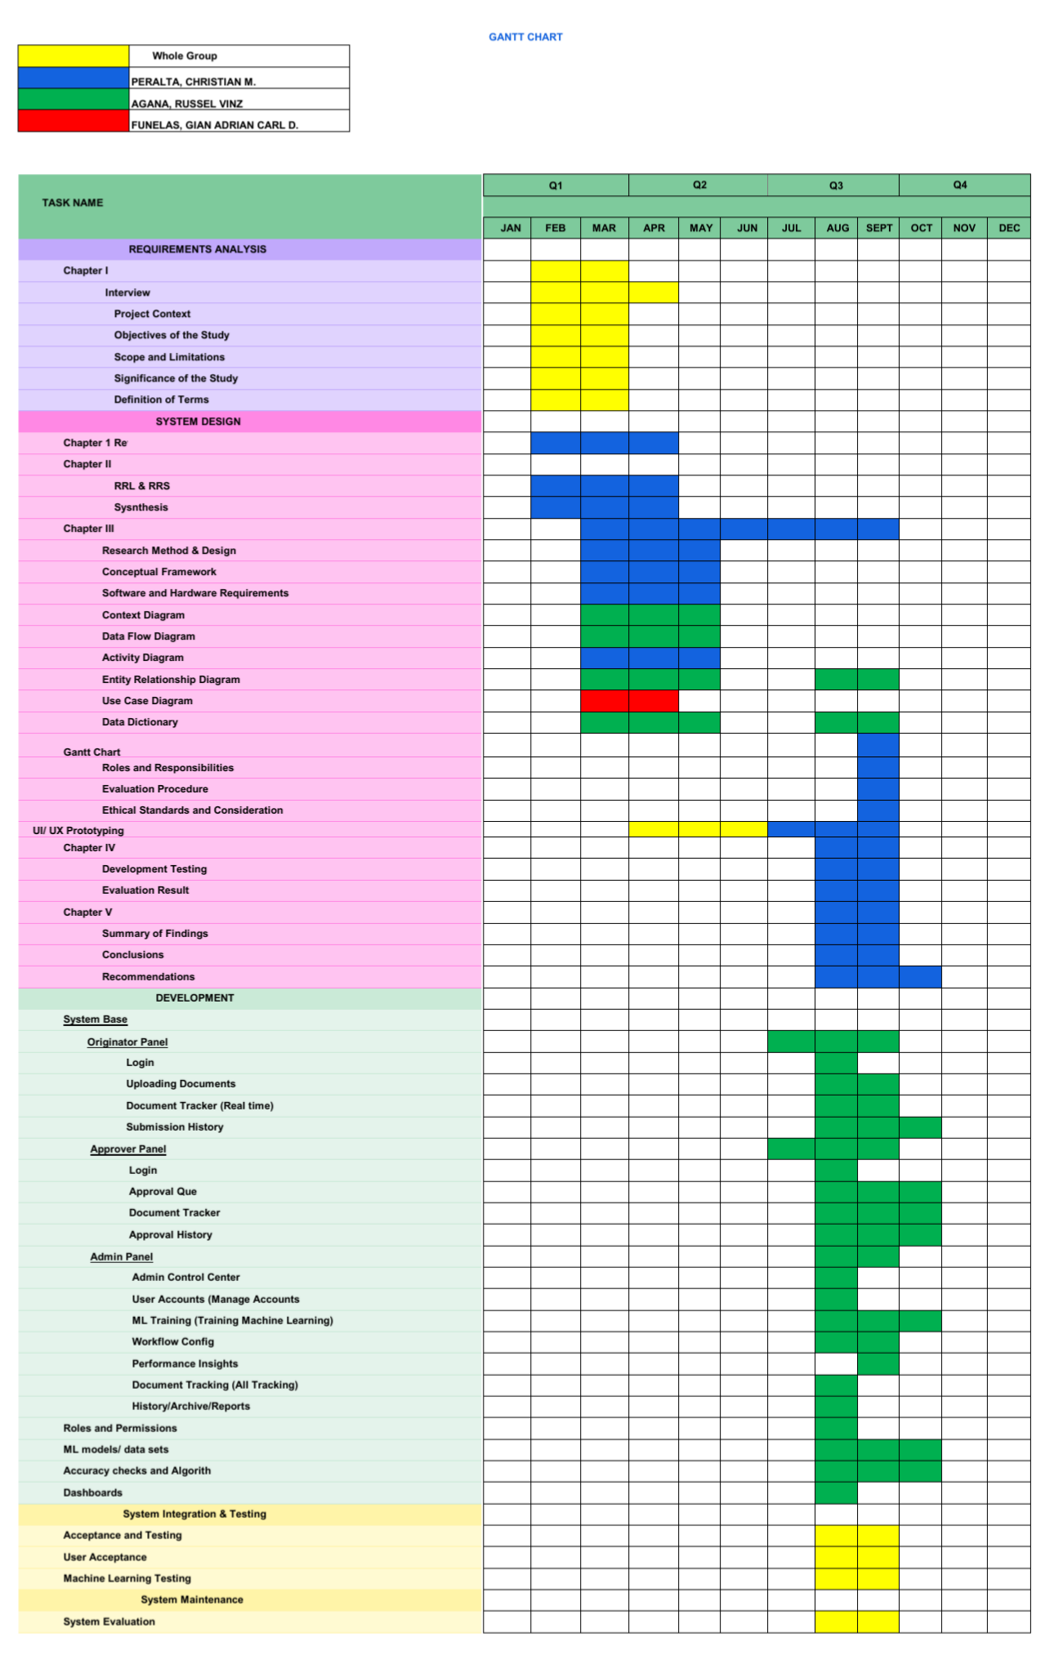
Figure 15. Gantt Chart
This Gantt chart represents the monthly timeline of the An Automated Document Classification and Tracking System Using Machine Learning capstone project from January to December. It illustrates the project schedule across four quarters (Q1-Q4), showing the timing and duration of all major project phases including Requirements Analysis, System Design & Documentation, Development, and Testing & Evaluation. The chart displays task allocation among the three team members: Peralta, Christian M. (Blue), Agana, Russel Vinz (Red), and Funelas, Gian Adrian Carl D. (Green), with collaborative tasks shown in yellow. The horizontal bars indicate when each task was executed, demonstrating the sequential and parallel workflow of system development, thesis documentation, and project completion leading to the capstone defense in March 2026.
3.11 Roles and Responsibilities
Russel Vinz Agana serves as the Project Manager and System Developer & Lead. He oversees the overall system development and architecture design, manages project timelines and milestones, and leads the implementation of core system modules including document classification, validation, approval routing, real-time tracking, and the centralized repository. Agana is responsible for implementing the Laravel framework, Laravel Reverb WebSocket integration, and cloud deployment. He coordinates team efforts to ensure project compliance with guidelines, conducts code reviews to maintain quality standards, and presents the capstone project during defense.
Christian M. Peralta serves as Documentation Lead, Quality Test Manager, and UI/UX Designer. He leads the thesis writing and documentation of all chapters, conducts quality assurance and user acceptance testing, and designs the user interface for all system modules. Peralta ensures the user experience is intuitive for all user roles (Staff-Originator, Staff-Approver, Administrator), coordinates with UJF Corporation for user feedback, creates test cases and testing documentation, and prepares evaluation surveys to collect user feedback on system performance.
Gian Adrian Carl D. Funelas serves as Database Administrator and handles Data Gathering & Research. He designs and implements the MySQL database schema, sets up database security and access controls, optimizes database queries for performance, and manages data migration and backup procedures. Funelas conducts interviews with UJF Corporation staff to gather requirements, collects sample documents for ML model training, documents existing workflows and pain points, and conducts the literature review for the thesis.

3.12 Evaluation Procedure
The evaluation of the proposed system was conducted using an expert-based (supervisor of the company) evaluation approach to ensure the reliability and validity of the results. Instead of relying on general users, the system was assessed by qualified evaluators, including the company supervisor and IT-related professionals with knowledge in system development and document management processes.
This approach was selected to obtain more accurate and credible feedback, as the evaluators possess the technical expertise and domain knowledge necessary to assess the system's functionality, performance, and overall quality.
Table 21. Likert Scale Table
Rating Scale | Numerical Values | Descriptive Value
5 | 4.21 - 5.00 | Highly Acceptable
4 | 3.41 - 4.20 | Acceptable
3 | 2.61 - 3.40 | Neutral
2 | 1.81 - 2.60 | Unacceptable
1 | 1.00 - 1.80 | Totally Unacceptable
Table 22. Software Evaluation Summary
Software Criterion | Final Rating | Interpretation
Functionality Sustainability
Performance Efficiency
Reliability
Security
Compatibility
Usability

This document outlines the software quality characteristics and sub-characteristics used to evaluate the Automated Document Classification and Tracking System Using Machine Learning. The system was evaluated based on the ISO/IEC 25010 Software Quality Model, which includes the following criteria: Each criterion was measured using a 5-point Likert scale, where the evaluators rated the system according to their level of agreement with each statement.
Functional Suitability: This characteristic represents the degree to which the system provides functions that meet stated and implied needs.
● Functional Completeness: Degree to which the set of functions covers all specified tasks and user objectives.
● Functional Correctness: Degree to which the system provides accurate results when used by intended users.
● Functional Appropriateness: Degree to which the functions facilitate the accomplishment of specified tasks.
Performance Efficiency: This characteristic represents the degree to which the product performs its functions within specified time and throughput parameters.
● Time Behaviour: Degree to which response times and throughput rates meet requirements.
● Resource Utilization: Degree to which the amounts and types of resources (CPU, memory, storage) used meet requirements.
● Capacity: Degree to which the maximum limits of system parameters meet requirements.
Reliability: Degree to which the system performs specified functions under specified conditions for a period of time.
● Faultlessness: Degree to which the system performs functions without fault under normal operation.
● Availability: Degree to which the system is operational and accessible when required.

● Fault Tolerance: Degree to which the system operates as intended despite hardware or software faults.
● Recoverability: Ability to recover data and re-establish the desired state in the event of failure.
Security: Degree to which the system protects information and data based on authorization levels.
● Confidentiality: Ensures data is accessible only to those authorized.
● Integrity: Prevents unauthorized modification or deletion of data.
● Non-repudiation: Proof that actions or events have taken place.
● Accountability: Actions can be traced uniquely to the specific entity.
● Authenticity: Ability to prove the identity of a subject or resource.
● Resistance: Sustains operations while under attack from malicious actors.
Compatibility: Degree to which the system can exchange information or share environmental resources.
● Co-existence: Ability to perform functions efficiently while sharing an environment with other products.
● Interoperability: Ability of two or more systems to exchange and use information.
Usability: Degree to which the system can be used by specified users to achieve specified goals with effectiveness, efficiency, and satisfaction in a specified context of use.
- Appropriateness Recognizability: Degree to which users can recognize whether the system is appropriate for their needs and understand its core functionalities without extensive documentation.
- Learnability: Ease with which users can learn to use the system and perform required tasks, including document submission, approval workflows, and administrative functions.
- Operability: Degree to which the system has attributes that make it easy to operate and control, including intuitive navigation, clear workflows, and straightforward approval actions.
- User Error Protection: Ability of the system to protect users from making mistakes, such as validating document submissions before approval routing or confirming critical actions.
- User Interface Aesthetics: Degree to which the user interface is visually appealing, organized logically, and presents information in a clear and understandable manner.
- Accessibility: Ease with which users with varying technical proficiency levels and different roles (originators, approvers, administrators) can effectively use all system features without barriers.
Machine Learning Model Evaluation
The performance of the machine learning model used in the system was evaluated using standard classification metrics, including Accuracy, Precision, Recall, and F1-Score. These metrics were selected to assess the effectiveness of the SVM–TF-IDF classifier in correctly categorizing documents based on their textual content.
Accuracy – Measures the overall correctness of the model by determining the proportion of correctly classified documents out of the total number of documents.
Precision – Measures how many of the documents predicted as a certain class are actually correct, indicating the model's ability to minimize false positive results.
Recall – Measures how many actual documents of a certain class were correctly identified by the model, indicating its ability to minimize false negatives.
F1-Score – The harmonic mean of precision and recall, providing a balanced measure of the model's performance, especially when dealing with imbalanced datasets.
Table 23. Machine Learning Model Performance
Metric | Value
Accuracy
Precision
Recall
F1-Score

3.13 Ethical Standards and Considerations
The researchers observed appropriate ethical standards throughout the planning, development, implementation, testing, and evaluation of DocTrack. The researchers recognized their responsibility to protect the rights, privacy, confidentiality, and welfare of the individuals and organizations involved in the study. All information gathered from the beneficiary (UJF Corporation), respondents, and other stakeholders was treated responsibly and was used only for purposes directly related to the development and evaluation of the proposed system.
Informed Consent
Before conducting interviews, observations, surveys, and system evaluations, the researchers informed the participants about the purpose and nature of the study. The participants were provided with sufficient information regarding their involvement, the type of information that would be collected, and the intended use of the gathered information. Participation was voluntary, and the researchers obtained appropriate consent before collecting information from the participants.
Voluntary Participation
Participation in interviews, surveys, observations, and system evaluation was voluntary. The respondents were not forced or pressured to participate in the study. They were informed that they could decline to answer questions or withdraw their participation when appropriate without experiencing any penalty or negative consequence.
Privacy and Confidentiality
The researchers respected the privacy of all participants and maintained the confidentiality of information obtained during the study. Personal information, organizational records, business information, and other sensitive data were not disclosed to unauthorized individuals. Information that was not necessary for the objectives of the project was not collected. When presenting the results, the researchers avoided including unnecessary personally identifiable information.
Data Privacy and Protection
The researchers implemented appropriate measures to protect personal and organizational data collected during the project. Data were accessed only by authorized members of the research team and were used only for legitimate purposes related to the capstone project. Electronic files containing sensitive information were stored using appropriate security measures, while physical documents were kept in a secure location. DocTrack itself implements role-based access control, user authentication, and audit trails to ensure that only authorized users can access sensitive company documents. After the completion of the project and the required retention period of the institution, unnecessary data will be properly disposed of in accordance with applicable institutional policies and data protection requirements.
Data Security
Because the project involves the development and testing of an information technology system, the researchers considered the security of data and system resources. Access to the system was controlled through user authentication and authorization mechanisms. Test data were used whenever possible instead of unnecessary real sensitive information. The researchers also avoided exposing passwords, confidential records, database credentials, and other sensitive technical information in the project documentation or during public presentations.
Proper Use of Information
All information obtained from the beneficiary and participants was used solely for the stated purposes of the capstone project. The researchers did not use the collected information for personal, commercial, or unrelated purposes without appropriate authorization. Information provided by UJF Corporation was treated as confidential when requested by the organization.
Intellectual Property and Proper Acknowledgment
The researchers respected the intellectual property rights of authors, developers, organizations, and other content creators. Information obtained from books, journals, websites, software documentation, frameworks, libraries, images, and other sources was properly acknowledged and cited. The researchers did not claim the work of other individuals as their own. Third-party software, libraries, frameworks, and other resources were used in accordance with their applicable licenses and terms of use. DocTrack utilizes Laravel, Blade templating, MySQL, and the php-ai/php-ml library, all of which are used in accordance with their respective open-source licenses.
Honesty and Research Integrity
The researchers maintained honesty and integrity throughout the conduct of the project. Data, testing results, survey responses, and evaluation results were reported accurately. The researchers did not fabricate, falsify, manipulate, or intentionally omit results to produce a more favorable outcome. Any limitations, errors, or unsuccessful test results encountered during the development and evaluation of the system were documented and considered appropriately.
Responsible System Development
The researchers considered the possible effects of the developed system on its intended users and beneficiary organization. DocTrack was designed to support legitimate organizational activities (automated document classification and approval tracking) and to minimize unnecessary risks to users and data. The researchers also considered usability, security, reliability,
and accessibility during system development and testing. The system implements transparency in ML classification results, fair load-balanced approver assignment, and comprehensive audit trails. Any known limitations of the system were communicated appropriately to the beneficiary.
Conflict of Interest
The researchers maintained professional objectivity throughout the project. Any personal, financial, or organizational relationship that could potentially influence the development, testing, evaluation, or reporting of the project was disclosed to the appropriate adviser or institution. The researchers ensured that the presentation of results was based on actual findings rather than personal interests.
Ethical Responsibility of the Researchers
Overall, the researchers committed themselves to responsible and ethical conduct throughout the capstone project. They ensured that the rights and interests of the participants and beneficiary organization were respected, that collected information was handled securely and confidentially, and that the results of the project were presented truthfully. Ethical considerations were observed not only during data gathering but throughout the entire software development life cycle, including requirements analysis, design, development, testing, implementation, evaluation, documentation, and presentation.

CHAPTER 4

RESULTS AND DISCUSSION
This chapter presents the results and detailed discussion of the system's development, focusing on how each of the study's specific objectives was achieved. The chapter is structured to correspond with the five specific objectives set out in Chapter 1, each addressing a critical component of the system's functionality.

4.1 Development and Testing
Specific Objective 1
Develop an Admin Control Center dashboard to monitor and analyze operational inefficiencies including approval delays, processing metrics, and rejection rates.
Figure 16. Admin Control Center Dashboard for Monitoring Operational Inefficiencies 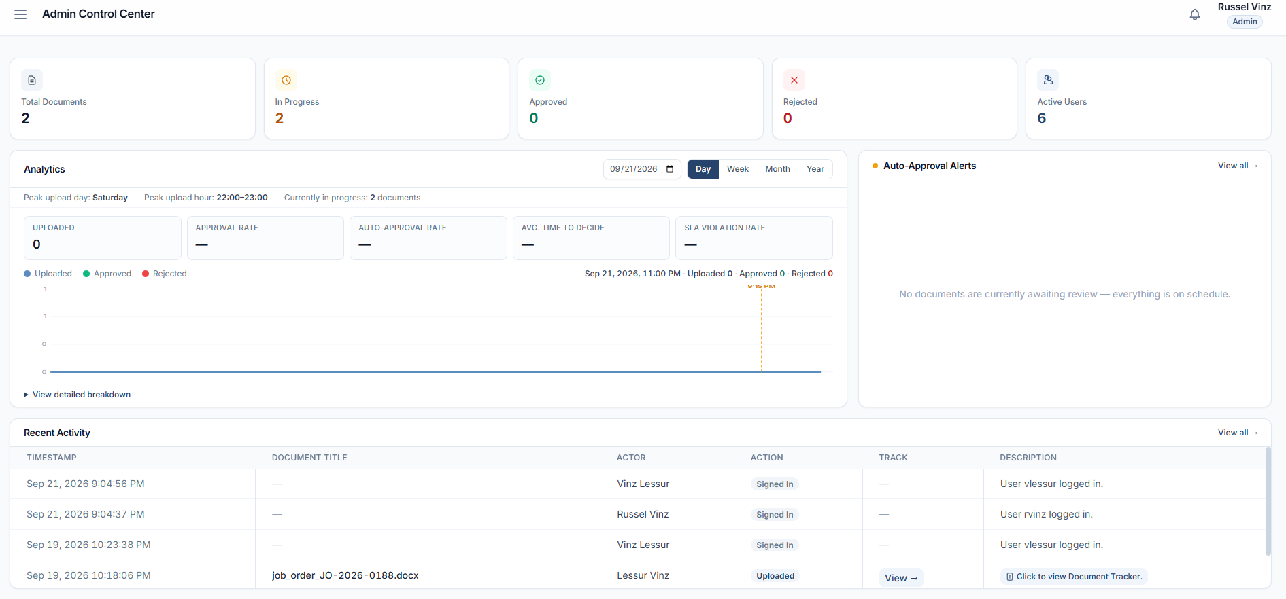
The Admin Control Center dashboard displays key performance indicators (KPIs) for monitoring and analyzing operational inefficiencies at UJF Corporation. The dashboard presents total document count, status distribution (In Progress, Approved, Rejected), and active user count for immediate workflow visibility. The Analytics section reveals processing metrics including approval rate, auto-approval rate, average time to decide (measuring approval delays), and peak upload patterns through visual charts. SLA Violation Rate tracking and Auto-Approval Alerts (showing "No documents are currently awaiting review — everything is on schedule") enable identification of approval bottlenecks and processing delays. The Recent Activity log provides an audit trail of all system actions with timestamps, actors, and descriptions. Together, these elements enable administrators to monitor approval delays, track processing efficiency, analyze rejection rates, and make data-driven decisions to optimize document workflow performance.
Specific Objective 2
Develop an automated document classification module using Support Vector Machine (SVM) with Term Frequency – Inverse Document Frequency (TF-IDF) to accurately categorize submitted documents and reduce misclassification and processing time.
Figure 17: Originator document submission screen, showing an uploaded document with its assigned category and confidence-based classification result
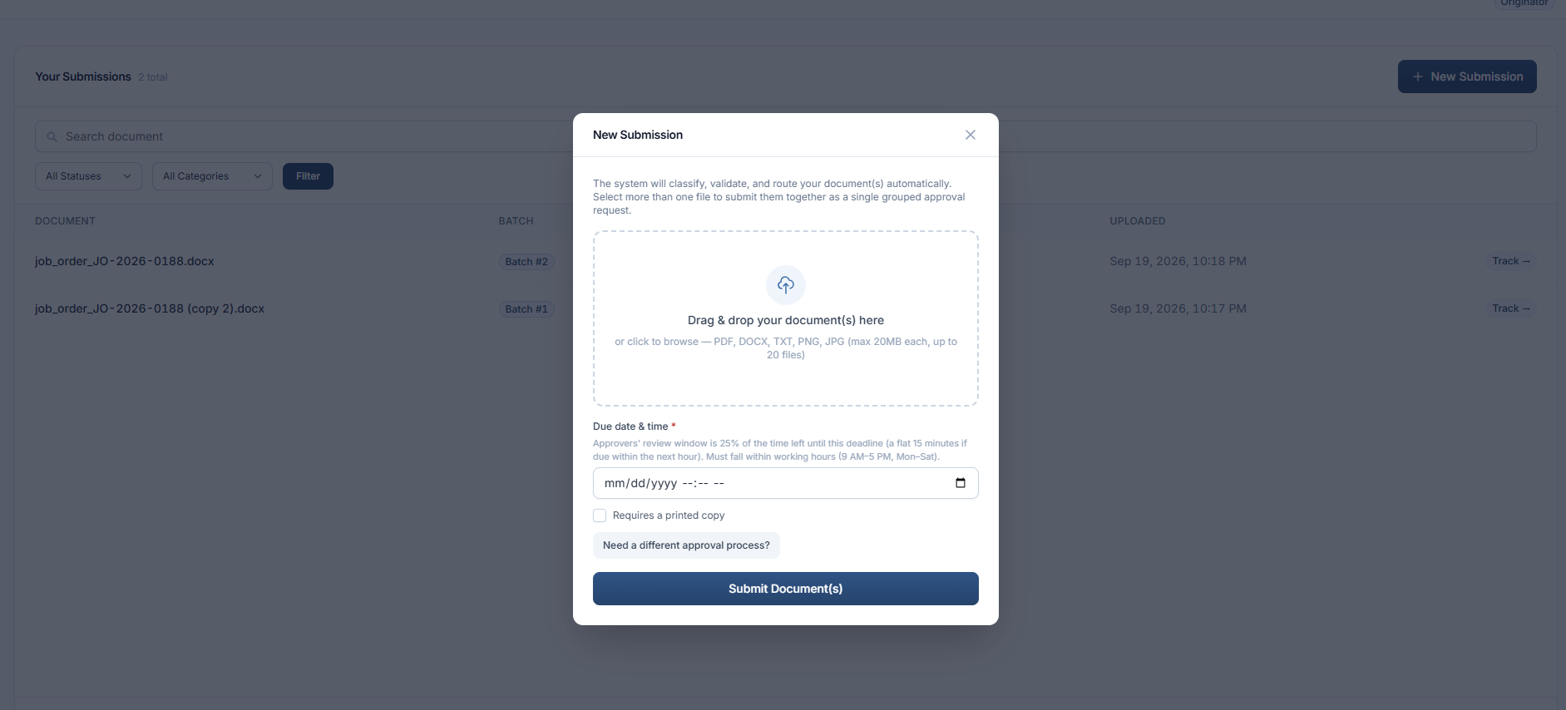
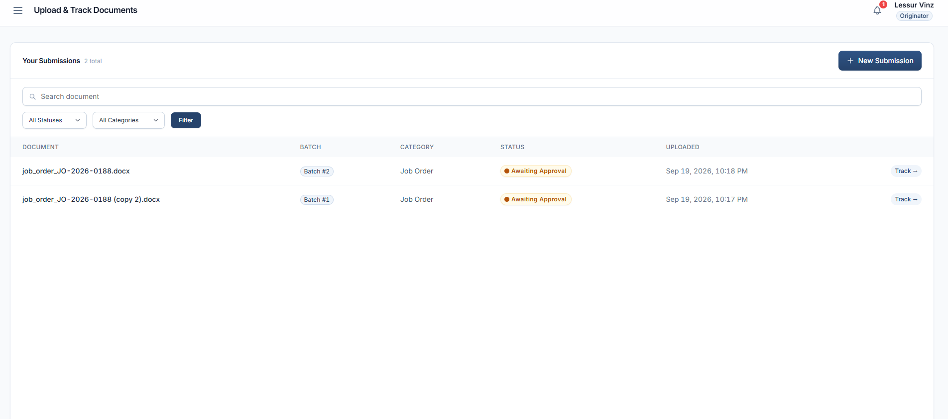
This figure presents the document submission interface where an originator uploads a document and the system automatically classifies it. Once submitted, the document's text is extracted (digitally or via OCR fallback), passed through TF-IDF feature extraction, and classified by the trained SVM model into one of the predefined categories. The classification result is displayed to the originator immediately, addressing the objective of reducing misclassification and processing time compared to the previous manual sorting process.
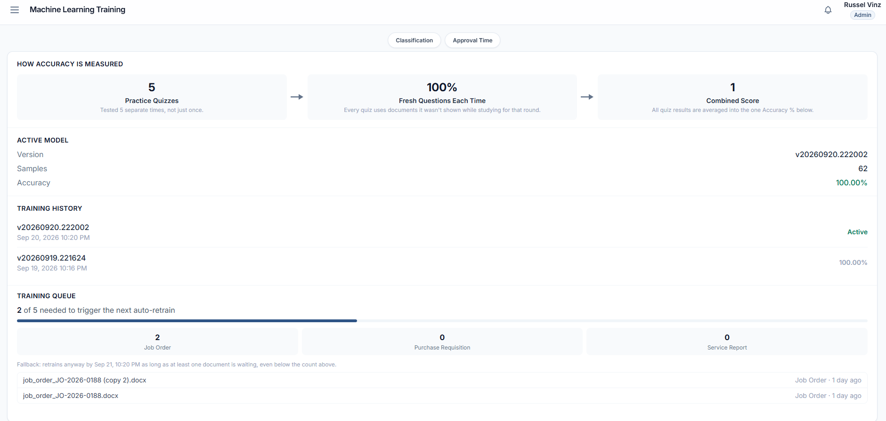
Figure 18. ML Training interface for classifier management with training samples, model metrics, and version history.

The Machine Learning Training interface enables administrators to build and continuously improve the SVM + TF-IDF classifier by uploading and staging training samples for each document category. Administrators can upload training files in batches (up to 20 per upload), and staged samples accumulate across multiple uploads with no upper limit on total training data. The interface displays the count of staged samples per category and provides options to review or remove individual samples before training. The Current Active Model panel shows the deployed model's version, total training samples, and estimated accuracy. The Training History section tracks all previous model versions with their training timestamps and accuracy metrics, enabling administrators to monitor classifier performance evolution and compare different model iterations. This continuous improvement approach allows the classifier to become increasingly accurate as more representative training data is accumulated from actual document submissions.
Specific Objective 3
Design and implement a document validation module that ensures completeness and correctness of submitted documents before they enter the approval workflow.
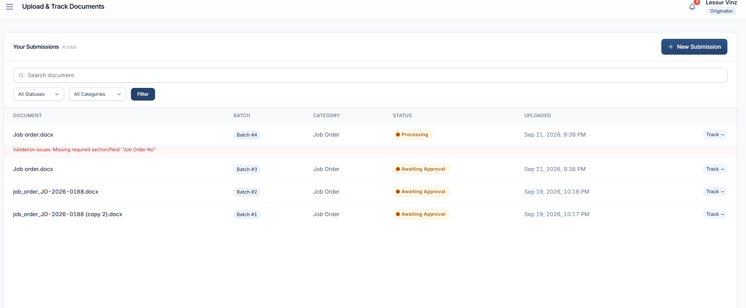
Figure 19: Validation result / rejected-submission screen showing the specific missing fields or formatting errors flagged by the system

This figure shows the automated validation step that runs immediately after classification. The system checks the submitted document against the required sections, mandatory fields, and formatting standards for its assigned category, and either allows it to proceed to routing or returns it to the originator with the specific validation errors listed. This prevents incomplete or improperly formatted documents from ever reaching an approver, directly addressing the objective.
Specific Objective 4
Develop a workflow management system that automates document routing, approval, and real-time status tracking across all stages of the approval process.
Figure 20: Approver's assignment queue showing pending documents, SLA deadline countdown, and Approve/Reject controls.
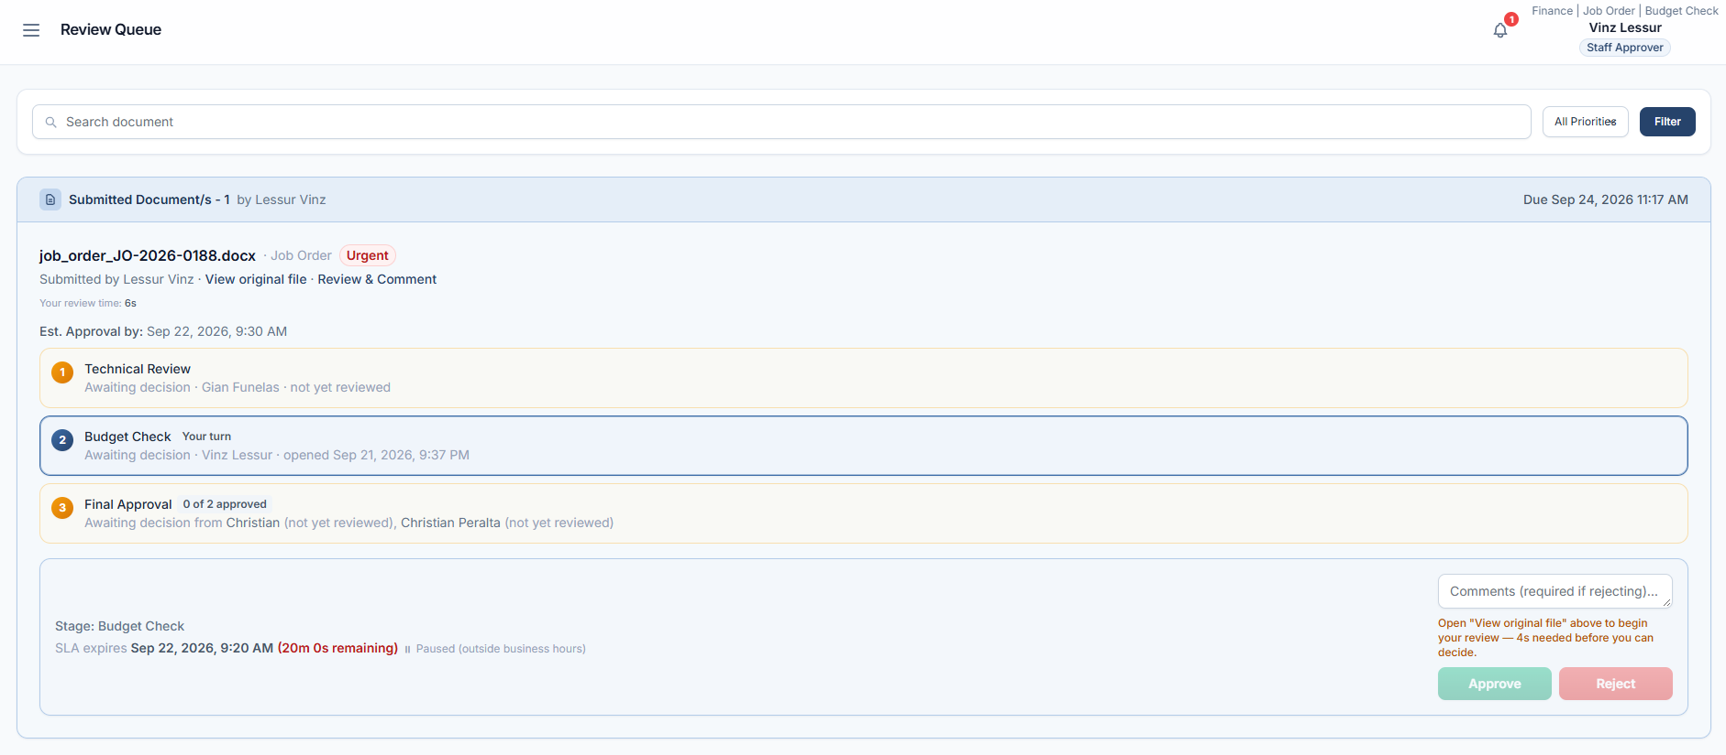
Figure 21: Originator's tracking view showing the document's current stage and live status updates
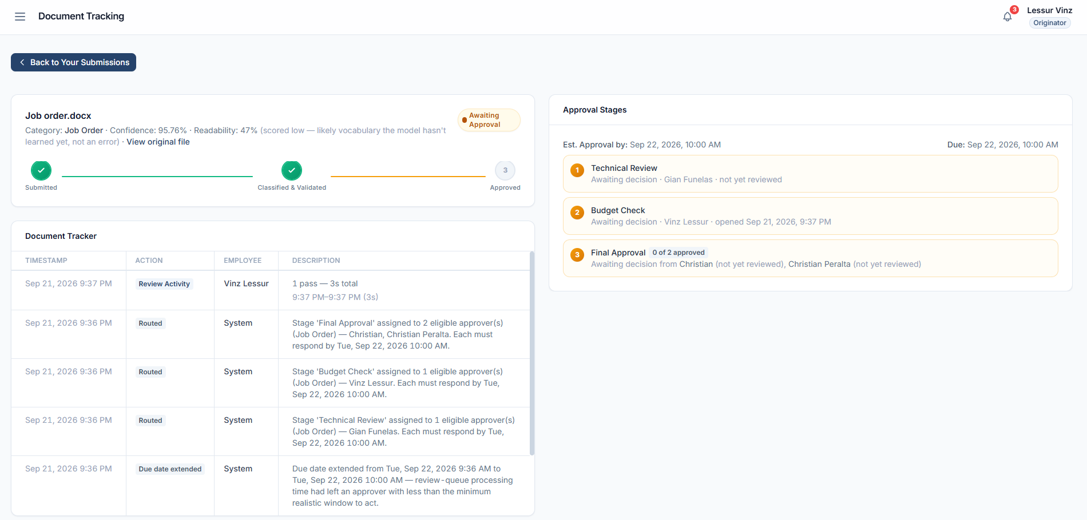
Figure 20 presents the approver-facing side of the workflow: once a validated document is automatically routed to the correct stage and approver, it appears in their queue with a visible SLA countdown, and the approver can approve, reject, or (in batch) decide on multiple documents at once. Figure 21 presents the originator-facing side: the same document's progress is visible in real time, updating live as it moves through each stage without the originator needing to follow up manually. Together these address the objective's routing, approval, and real-time tracking requirements.
Specific Objective 5
Create a centralized digital repository that enables efficient storage, search, and retrieval of approved documents.
Figure 22: Archive module showing the searchable/filterable list of approved documents with a download action
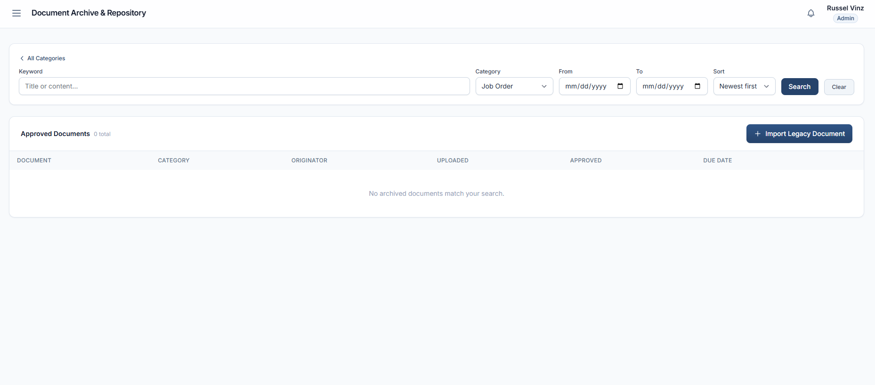
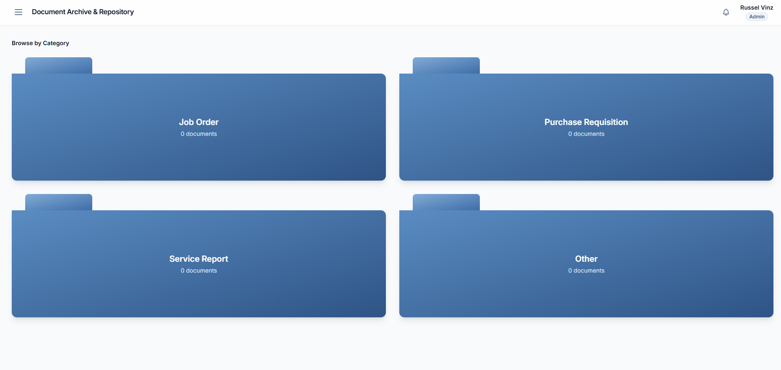
This figure presents the centralized archive where every finalized document is stored and made searchable by title, category, date, or originator. Any authorized user can locate and retrieve a previously approved document directly from this view, replacing the manual, physical-storage-dependent retrieval process that existed before the system.

The testing was conducted to validate whether DocTrack meets quality standards, functions as intended, and satisfies users' needs. The evaluation used the ISO 25010 Software Quality Model framework to ensure a comprehensive assessment across different quality characteristics including Functionality, Sustainability, Performance Efficiency, Reliability, Security, Compatibility, and Usability.

Unit and Integration Testing
Machine Learning Model Performance:
The SVM + TF-IDF classification model was evaluated using standard ML performance metrics including classification accuracy, precision, recall, and F1-score across all three document categories (Job Order, Purchase Requisition, Service Report). Model performance was validated against a test dataset of manually classified documents to ensure reliable automated categorization before deployment.
The testing involved three main groups of respondents:
- Staff-Originators: Users who submit documents for approval and track their processing status through the system.
- Staff-Approvers: Users who review validated documents, approve or reject submissions, and manage their assigned approval queues based on document category.
- Administrators: System managers who oversee ML model training, workflow configuration, SLA management, user account creation, and system performance monitoring.
User Acceptance Testing
The evaluation used a Likert scale rating system where respondents rated different aspects
of the system. The interpretation criteria table was:
Table 21. Likert Scale Table
Rating Scale | Numerical Values | Descriptive Value
5 | 4.21 - 5.00 | Highly Acceptable
4 | 3.41 - 4.20 | Acceptable
3 | 2.61 - 3.40 | Neutral
2 | 1.81 - 2.60 | Unacceptable
1 | 1.00 - 1.80 | Totally Unacceptable

Table 24. Software Evaluation of Functional Suitability Criterion

Criterion | Sub-Criterion | Rating | Interpretation
Functional Suitability | Staff-Originator: How effectively does the system classify and validate your submitted documents before routing to approval?
Functional Suitability | Staff-Approver: How effectively does the system route validated documents to you and ensure document quality in your approval queue?
Functional Suitability | Administrator: How well does the system work correctly for document organization and approval management?
Overall Rating

Table 25. Software Evaluation of Performance Efficiency Criterion

Criterion | Sub-Criterion | Rating | Interpretation
Performance Efficiency | Staff-Originator: How quickly does the system process and route your documents from submission to approver assignment?
Performance Efficiency | Staff-Approver: How effectively does the system provide real-time status updates as documents move through approval stages?
Performance Efficiency | Administrator: Does the system handle documents smoothly without slowdowns?
Overall Rating

Table 26. Software Evaluation of Reliability Criterion
Criterion | Sub-Criterion | Rating | Interpretation
Reliability | Staff-Originator: How consistently does the system accurately classify your documents into the correct category?
Reliability | Staff-Approver: Does the system reliably track approval deadlines and remind you when due dates are close?
Reliability | Administrator: Does the system consistently produce correct results for document categorization and routing?
Overall Rating

Table 27. Software Evaluation of Security Criterion
Criterion | Sub-Criterion | Rating | Interpretation
Security | Staff-Originator: How well does the system protect your documents and personal information from unauthorized access?
Security | Staff-Approver: How effectively does the system control access to ensure only authorized approvers can view and approve documents?
Security | Administrator: How well does the system maintain secure audit trails and enforce role-based access control?
Overall Rating

Table 28. Software Evaluation of Compatibility Criterion
Criterion | Sub-Criterion | Rating | Interpretation
Compatibility | Staff-Originator:Does the system work well on the different devices and browsers you use?
Compatibility | Staff-Approver: Does the system work smoothly with your organization's existing tools and processes?
Compatibility | Administrator: Does the system work well on different devices and browsers used by staff in your organization?
Overall Rating

Table 29. Software Evaluation of Usability Criterion
Criterion | Sub-Criterion | Rating | Interpretation
Usability | Staff-Originator: How easy is it to submit documents and understand the submission process?
Usability | Staff-Approver: How easy is it to view, review, and approve documents using the system?
Usability | Administrator: How easily can you configure workflows, training data, and system settings?
Overall Rating

References
Aclan, J., Barnobal, K., Lumacang, J., & Montes, M. J. (2024). Challenges on record management of Barangay Sta. Lucia Novaliches, Quezon City: Personnel & constituents. Ascendens Asia Singapore – Bestlink College of the Philippines Journal of Multidisciplinary Research. https://ojs.aaresearchindex.com/index.php/aasgbcpjmra/article/view/13567
Ali, A. V. T. (2025). Enhancing project responsiveness and efficiency using real-time tracking for Schools Division Office of Batangas City. International Journal of Research and Scientific Innovation, 12(13). https://doi.org/10.51244/IJRSI.2025.1213CS0014
Ali, S. H., & Al-Mamari, R. (2025). Toward effective digital records management in Oman: Key enablers, barriers, and policy implications.
Alotaibi, M. B. (2021). Electronic records management and organizational productivity: An empirical study of public sector organizations. Records Management Journal, 31(2), 124–142. https://doi.org/10.1108/RMJ-07-2020-0022
Alzahrani, A., & Di Troia, F. (2022). Document classification using text-based features for intelligent organizational records management. Applied Sciences, 12(14), 6929. MDPI. https://doi.org/10.3390/app12146929
Angala, D. T., Casugay, B. C. O., Estillore, H. M. Q., Lebantino, J. B., Marcha, S. O., & Villanueva, G. R. Jr. (2023). Development and implementation of document management system for Ilocos Sur Polytechnic State College, Tagudin Campus. E-DAWA: An International Multidisciplinary Research Journal, 3(Special Issue). https://ispsc.edu.ph/e-dawa-hpcb6748
Asatiani, A., Malo, P., Rinta-Kahila, T., & Penttinen, E. (2023). Challenges and best practices for enterprise document workflow automation: An empirical investigation. MIS Quarterly Executive, 22(1), 45–60.
Bagano, J. K. F. (2023). Digital document indexing for improved records custodianship of planning documents [Master's Thesis, De La Salle University]. Animo Repository. https://animorepository.dlsu.edu.ph/etdm_manorg/158/
Balangat, E. S. (2025). Status of the records management system of LGU Calanasan: Recommendation for records management system. ISRG Journal of Arts, Humanities and Social Sciences.
Buctuanon, M. M., Gadiane, J. L. A., Margallo, F. A., & Lucero, P. R. (2021). Incorporating rule-based pattern recognition approach for document structure classification on cloud-based document management system. Mindanao Journal of Science and Technology, 19(2). https://mjst.ustp.edu.ph/index.php/mjst/article/view/999
Cruz, J. C. B., & Cheng, C. (2022). Improving large-scale language models and resources for Filipino. In Proceedings of the Thirteenth Language Resources and Evaluation Conference (pp. 6548–6555). European Language Resources Association. https://aclanthology.org/2022.lrec-1.703/
Digital transformation in the records management of a private higher-education institution. (2025). International Journal of Management and Applied Digital Innovation.
Dogo, E. M., Nwulu, N. I., Twala, B., & Aigbavboa, C. (2022). A survey of machine learning methods applied to anomaly detection in organizational information systems. Symmetry, 14(1), 13. MDPI. https://doi.org/10.3390/sym14010013
Enaño, J. V., Natividad, K. P., Pantoja, D. R., Ebi, F. C. D., Bautista, J. V., & Cura, D. (2025). BarangayConnect: A web-based information portal for resident data, administrative services, and community records using data analytics and linear regression algorithms. International Journal of Research and Innovation in Social Science, 9(10). https://doi.org/10.47772/IJRISS.2025.910000127
Gasparetto, A., Marcuzzo, M., Zangari, A., & Albarelli, A. (2022). A survey on text classification algorithms: From text to predictions. Information, 13(2), 83. MDPI. https://doi.org/10.3390/info13020083
Gill, S. S., et al. (2022). AI for next-generation computing: Emerging trends and future directions. Internet of Things, 19, 100514. Elsevier. https://doi.org/10.1016/j.iot.2022.100514
Hutchinson, A., & Warren, M. (2021). Digital transformation and records management in public sector organizations: A systematic literature review. Records Management Journal, 31(1), 37–53. https://doi.org/10.1108/RMJ-05-2020-0013
Li, Q., Peng, H., Li, J., Xia, C., Yang, R., Sun, L., Yu, P. S., & He, L. (2022). A survey on text classification: From traditional to deep learning. ACM Transactions on Intelligent Systems and Technology, 13(2), 1–41. https://doi.org/10.1145/3495162
Mbanaso, U. M., & Dandaura, E. S. (2021). Intelligent document tracking and management system architecture for government organizations. International Journal of Computer Science and Information Security, 19(2), 1–10.
Minaee, S., Kalchbrenner, N., Cambria, E., Nikzad, N., Chenaghlu, M., & Gao, J. (2021). Deep learning–based text classification: A comprehensive review. ACM Computing Surveys, 54(3), 1–40. https://doi.org/10.1145/3439726
Nkholedzeni, S. N. (2022). Records management practices and the impact on service delivery in a public sector organization. South African Journal of Information Management, 24(1), 1–9. https://doi.org/10.4102/sajim.v24i1.1541
Opel Inc. (2025). Top challenges businesses face with manual document processes. https://www.opex.com/insights/top-challenges-businesses-face-with-manual-document-processes/
Ouedraogo, W. S., Benbrahim, H., & Berrada, I. (2022). Automated document workflow management and audit trail generation for enterprise governance. Knowledge-Based Systems, 254, 109638. https://doi.org/10.1016/j.knosys.2022.109638
Peramo, E., Cheng, C., & Cordel, M. (2021). Juris2vec: Building word embeddings from Philippine jurisprudence. In 2021 International Conference on Artificial Intelligence in Information and Communication (ICAIIC) (pp. 121–126). IEEE.
Qaddoumi, N. A. E. (2025). Development of an electronic records-keeping with enhanced classification and organized retention and disposal system (E-RECORDS). AIDE Interdisciplinary Research Journal, 11(1), 270–279. https://doi.org/10.56648/aide-irj.v11i1.184
Ramos, M. C., & Yazon, A. D. (2021). Digital readiness and challenges in e-records management among LGUs in the Philippines. Asia Pacific Journal of Multidisciplinary Research.
Raralio, D. G., Manzano, W. Q., & Lomibao, A. N. L. (2025). Development of document tracking and archiving system for procurement management office's purchase request in Apayao State College. International Journal of Research and Scientific Innovation, 12(7), 1290–1308.
Rojas, M. V., & Garcia, F. J. (2023). Automated document workflow and real-time tracking in medium-sized organizations: Design and evaluation. Computer Standards and Interfaces, 83, 103637. https://doi.org/10.1016/j.csi.2022.103637
Sarker, I. H. (2021). Machine learning: Algorithms, real-world applications and research directions. SN Computer Science, 2(3), 160. Springer. https://doi.org/10.1007/s42979-021-00592-x
Serhani, M. A., El Kassabi, H. T., Ismail, H., & Navaz, A. N. (2021). ML pipeline: A unified machine learning workflow framework for organizational information systems. IEEE Access, 9, 97387–97413. https://doi.org/10.1109/ACCESS.2021.3094777
Smeets, R., Rommelse, J., & Hoppenbrouwers, S. (2022). Automated workflow systems for compliance in document-intensive organizational processes. International Journal of Healthcare Management, 15(2), 105–115. https://doi.org/10.1080/20479700.2022.2057819
Smith, M. A., & de Vet, P. (2022). Enterprise content management and organizational compliance: A framework for records governance. International Journal of Information Management, 62, 102420. https://doi.org/10.1016/j.ijinfomgt.2021.102420
Tamburis, O., Esposito, C., & Comito, C. (2022). Workflow management systems for document tracking in distributed enterprise environments. Future Generation Computer Systems, 127, 1–14. https://doi.org/10.1016/j.future.2021.09.002
Te, G. M. I. (2022). Exploring the use of pre-trained transformer-based models and semi-supervised learning to build training sets for text classification [Master's Thesis, De La Salle University]. Animo Repository. https://animorepository.dlsu.edu.ph/etdm_softtech/6/
van der Aalst, W. M. P., Bichler, M., & Heinzl, A. (2021). Robotic process automation. Business and Information Systems Engineering, 63(2), 269–272. https://doi.org/10.1007/s12599-021-00693-2
Wewerka, J., & Reichert, M. (2022). Robotic process automation: A systematic mapping study and classification framework. Enterprise Information Systems, 17(2), 1–58. https://doi.org/10.1080/17517575.2021.1986862

